Anticipatory conservation based drought management of water supply reservoirs

M. Adibi
Civil Engineering department, I.U.S.T. , Tehran 16844, I.R. Iran

M. A. Collins
(Former) Professor of Civil Engineering, S.M.U. , Texas, U.S.A. (

Abstract

A new methodology has been developed and evaluated for making long-term forecasts for the dry and wet period phenomenon. This study emphasizes the use of actual data as opposed to synthetic data. This is extremely valuable for the reservoir water manager dealing with the actual data as opposed to artificial data, which may or may not be materialized. Utilization of the method significantly improves storage reservoir management and also acts as a valuable tool in sizing the needed capacity of the existing or non-exciting reservoir systems.

Introduction

Extreme hydrologic variation often has significant effects on man and his society. Drought episodes are one type of hydrologic variation which can cause significant technical, management, economic, and social problem. The impact of severe drought in arid and semiarid areas which are agriculturally productive is quite apparent.

Traditionally, reservoir development coupled with conservation strategies has been utilized to minimize the adverse effect of drought. As a consequence, the engineer has had to determine the size of reservoirs to be constructed to provide adequate water supplies during future drought of unknown magnitude and duration.

Now the question arises: how adequate is the plan that incorporates information on potential severity and duration of the drought for dealing with the adverse consequences of a drought?

Method and Approach

The present methodology utilizes historical stream flow data based on water year discharge. Each transformed set of data (annual flow for each river reduced to unit mean and summed) is plotted in the form of cumulative departure from cumulative mean flow. Then, in relation to the long term storage capacity phenomenon (Hurst, 1951) The range statistic is formed as a boundary range curve and ultimately intersected with the linear model which already has been fitted to the regions of the realization curves. The linear model is based upon the existing correlation between duration and severity of events (wet–dry period) in every sequence of data. The intersection points are in fact the theoretical location of the diversion points on the realization curve. Implementation of this process by the means of the two above functions (i.e. boundary range curve and the linear model) along the path of the realization curve makes it feasible, even if only approximately, to predict the future pattern of the cumulative sum inflow into an existing of hypothetical reservoir.

Generally speaking, the uniqueness of each trend line and the diversion points will be powerful enough to act as a driving force to construct a linear extrapolation model for wet and dry periods separately in the set of data. In other words, the combination of the linear model and the boundary range curve will provide forecast information to determine an extreme event of the realization curve as described in terms of its magnitude and duration. Therefore, this procedure acts as a long - term anticipatory draught tool that incorporates both stochastic and deterministic features.

The stochastic nature of a random variable such as river flow can not be ignored. Therefore, no one can speak to the storage problem of a reservoir in a purely deterministic way. Each transformed data set represents one of the stochastic realizations of the potential multi – realization of stream flow. Analysis of such a sequence as a time series on a basis of only one realization is analogous to analyzing the properties of a random variable on the basis of a single observation. Due to this fact, the proposed method is considered to be a combination of stochastic and deterministic features. However, this work will not lead to the conventional time series approach.

It is important to clarify that by the method developed in this research no attempt has been made to establish a method based on a drought probability distribution function (pdf) or a combination of Monte Carlo simulation techniques which requires a huge number of synthetic data. On the contrary, the present method tries to address the problem by describing what really does occur over a single realization curve in the future. The answer, i.e. the time and magnitude of the extreme event, is single and specific. Remember, this realization is the one which is actually occurring and the proposed answer is unique.

Range statistic

Initially consider a hypothetical reservoir whose volume is to be determined. For a sequential data set , say, of annual stream flows,Z₁ ,Z₂ ,Z₃ ,…,Z_{N} , the kth partial sum, S_{k} ,(k=1, 2, 3, …,N) , is defined as

$S=S_{k−1}+(Z_{k}−α^{'}Z_{N})=\sum{Z_{i}−α^{'}}{\text{kZ}}_{N}$ (1)

$α^{'}{\bar{Z}}_{N}$ is the reservoir draft and $α^{'}$, $(0≤α^{'}≤1)$ is a proportionally constant. The physical interpretation of $α^{'}$ in Equation (1) was discussed by McLeod and Hipel (1978). When $α^{'}$ = 1, the proportionality constant between storage and draft is the largest and the water in the inflowing river would be used to its full potential.

The maximum value of S_{k} from all N years over the entire record is called the maximum partial sum, M_{N}, or maximum surplus. The minimum value of S_{k} in the same sequence is called the minimum partial sum, m_{N} , or maximum deficit.
The cumulative range R_{N}, is defined as

$R_{N}=M_{N}−m_{N}$ (2)

where, M_{N} = max(0, S₁ ,S₂,…,S_{N}), for the maximum surplus, and m_{N} = min(0, S₁ ,S₂,…,S_{N}), for the maximum deficit, i.e.,

$R_{N}=\text{max}\left\{0,S_{1},S_{2},\text{.}\text{.}\text{.},S_{N}\right\}−\text{min}\left\{0,S_{1},S_{2},\text{.}\text{.}\text{.},S_{N}\right\}$ (3)

Note that R_{N} is a non- decreasing function over N years (see Figure 1)

The Hurst Phenomenon

Even though the behavior of the range statistic itself is not particularly useful for storage analysis (Sen 1997b), the idea of incorporation of the sample standard deviation with the range statistic was a striking discovery by Harold Edwin Hurst in 1951. He suggested a simple formula based upon long-term dependency of hydrologic sequences and the actual difference between the maximum and minimum cumulative flow from the historical mean flow.
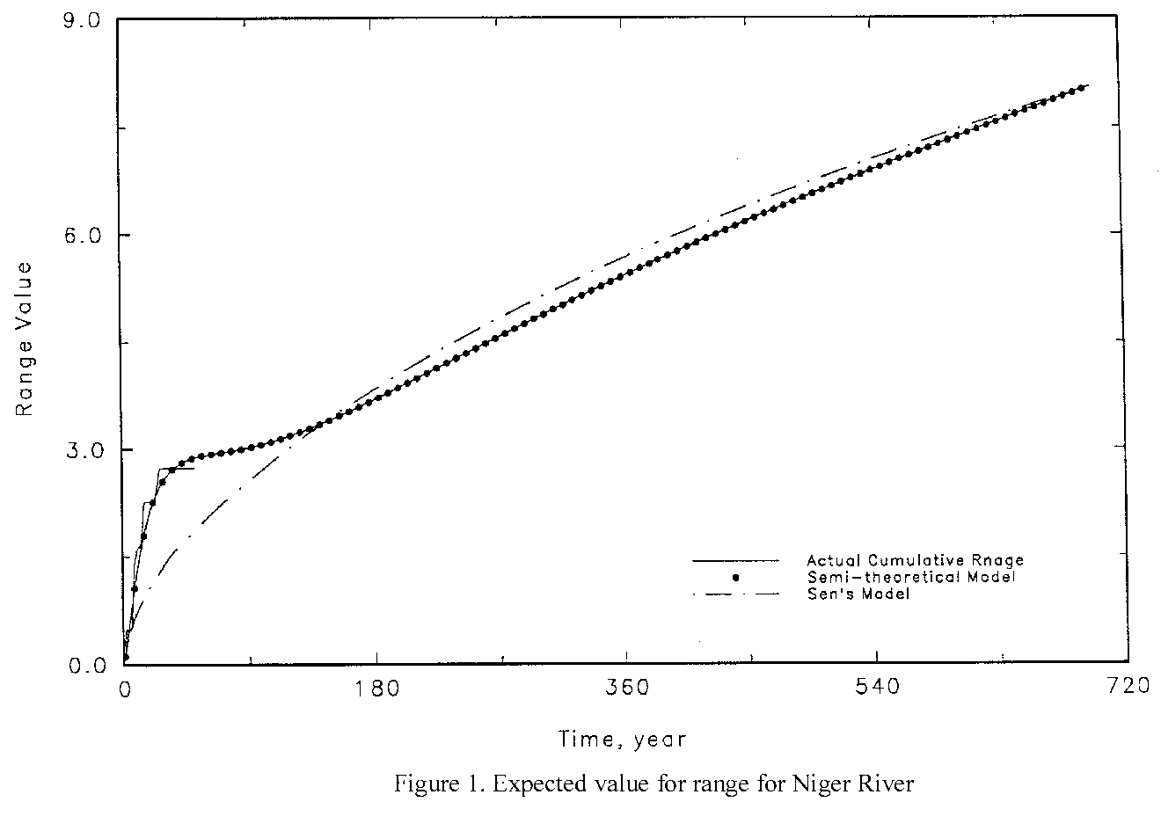
Basically, Hurst's empirical finding leads to

$\left(R_{N}/s_{N}\right)»R\left(N\right)$ (4)

where the function R(N) is the range statistic and s_{N} is the sample standard deviation with
$s_{N}=N^{−\frac{1}{2}}{\left\{\sum{{\left(Z_{i}−α{\bar{Z}}_{N}\right)}^{2}}\right\}}^{\frac{1}{2}}$ (5)

The importance of the range statistic is this. Hurst's work and those who followed him demonstrated that for very long geophysical sequences such as rainfall and stream flow , R_{N}/s_{N} varies as a power, h, of N. This power h, is the Hurst coefficient and is generally found to be about 0.73 with a standard deviation of 0.09 in the many sequences examined by Hurst (Kottegoda, 1980).

Focusing on the Hurst coefficient h, finally it appears in the well known relationship developed by Hurst(1951) as

$\left(R_{N}/s_{N}\right)={\left(N/2\right)}^{h}$ (6)

in which s_{N} is the sample standard deviation and h is the Hurst Coefficient.

If one wants to summarize all the research results by now, for the short-term persistent processes the value of h tends to be 0.5 and for long-term persistent processes the value is 0.5<h<1. The value of h=0.5 is a result of purely random normal process and quite firm in theory. However, the value of h=0.73 is also a well-documented empirical figure in hydrology (Kottegoda,1980; Wallis and Matalas,1970; Sen,1977; Klemes,1974) that does not support the theoretical value of 0.5. This difference, or discrepancy, is considered "The Hurst Phenomenon."

In the literature, two different estimators have been discussed for the population Hurst coefficient h. One is k, originally used by Hurst (1951), with the explicit form of
$k=\text{log}\left(R_{N}/s_{N}\right)/\text{log}\left(N/2\right)$ (7)

The other estimator is designated as H, (Wallis and Matalas,1970; Mandelbrot and Wallis, 1969). H and k are biased estimators, both asymptotically approaching 0.5 when the sample size is extremely large (Lawrence and Kottegoda, 1977; Sen, 1977a).

Estimate of the Hurst Coefficient h
It is evident that the present method must utilized annual long-term stream flow data. The Niger River in Africa with data from 1906 to 1956 was selected as a typical river to develop and illustrate the proposed methodology.

Based on a Gaussian assumption for the pdf for the stream flow, Sen(1977a) presented a theoretical expression to determine the k value. One may ask what would be a proper k magnitude without resorting to any pdf assumption. Clearly, a more appropriate model for k would be the one based on actual data reflecting the actual Hurst effect rather than one based on an Gaussian assumption behavior.

Following this direction of thought, one might first evaluate the Hurst coefficient through the observed data. Since

$R_{N}={\left(N/2\right)}^{k}∗s_{N}$ (8)
then
$\text{log}\left(R_{N}/s_{N}\right)=k\text{log}\left(N/2\right)$ (9)
$k=\frac{\text{log}\left(R_{N}/s_{N}\right)}{\text{log}\left(N/2\right)}$ (10)

where (R_{N} / s_{N}) is the adjusted re-scaled range, N is the sample size, and s_{N} is the standard deviation for the entire sample size. Equation(10) yields a series of k values because R_{N} and N are both known values from the historical record. By plotting the logarithm of k verses time and establishing a linear regression model, the natural behavior of k with respect to time, as reflected in the slope of the data, is demonstrated. The exponential form of the linear regression line is defined by

$\text{log}k=b−\text{aN}$ (11)

$\frac{k}{k_{0}}=e^{−\text{aN}}$ (12)

where b=log k_{o} and k=k_{o} at N=0.

It was found for the Niger River data, in taking the result from Equation (11) and applying it to Equation (8), that a poor fit was obtained to the range data. In other words, keeping track of the path of the actual cumulative range curve will not work well unless Equation (12) is modified. This modification, is based on the desired asymptotic behavior with trail and error refinement, is shown below in Equation (13). With the constraint of k_{o}=0.6 at N approaching infinity, the modified equation works quite well. The modified equation is

$\text{log}\left(k−0\text{.}6\right)=b−\text{aN}$ (13)

It is interesting to note that Sen's theoretical work (1977a) shows a similar behavior on his graphical presentation of expected values of k.

In summary, the above simple model conveys the following features: (1) the general behavior of the k values can be described by a modified exponential equation; and, (2) the lower bound on k found by trail and error to be 0.6 is consistent with the minimum possible value of 0.5.

Fitting model with constant coefficient

The practical significance of the real range evidenced in a data set is that it defines the minimal necessary reservoir volume to supply a demand equal to the mean flow over a drought period.

The range values are readily determined through long-term annual stream flow records. Mathematically describing the cumulative range values eventually leads to a model for the expected value of the range which is the required information for the prediction of reservoir requirements.

The key factor in accomplishing this task is the identification of a proper k value for the empirical range equation found by Hurst (1951). A sequence of k values based on Equation (13) provides a satisfactory result for describing the range behavior (see Figure 1). Thus, the two step procedure for defining a range model is:(1) make a regression analysis for k, using the modified exponential Equation (13); and (2) substitute that k into the empirical range equation. The final form will be

$R_{N}=\left[{\left(N/2\right)}^{\left\{k_{0}+{\text{10}}^{−\left[a∗N−b\right]}\right\}}\right]∗s_{N}$ (14)

where N is time from the beginning of the record, k_{o}=0.6 an empirical value which is the initial value of estimator of h, s_{N} is the standard deviation of the streamflows, and a and b are the regression coefficients for the modified k model.

The above version of the range equation furnishes a reasonably well-fitting model to the observed range data for the Niger River (see Figure 1) as well as the 9 other rivers selected from three different parts of the world for analysis. However, the model need not necessarily be a perfect fit. Figure (1) shows the observed range curve has a stair-case type of upward movement which is not making such a perfect fit; but the underlying idea is merely to find the trend of the actual data.

Because Equation (14) can empirically describe the range phenomenon as based on the Hurst empirical theory and is also consistent with the theoretical results shown by Sen (1977a), it can be called a semi-theoretical model for range calculation.

The semi-theoretical model serves as a theoretical boundary limit for the maximum-minimum variation (largest deficit and surplus) of the realization curve. Therefore, the term “boundary range curve” will be used interchangeably for semi-theoretical model. Figure (2) illustrates the boundary range curve for the Niger with the historical data of 50 years.

The realization curve

In order to prepare the realization curve defined earlier, one may calculate annual stream flows reduced to unit mean, summed them, and then subtract from each flow the mean flow based on the summed total (a process of normalization) to produce the curve which is deviation of flow from the mean flow.
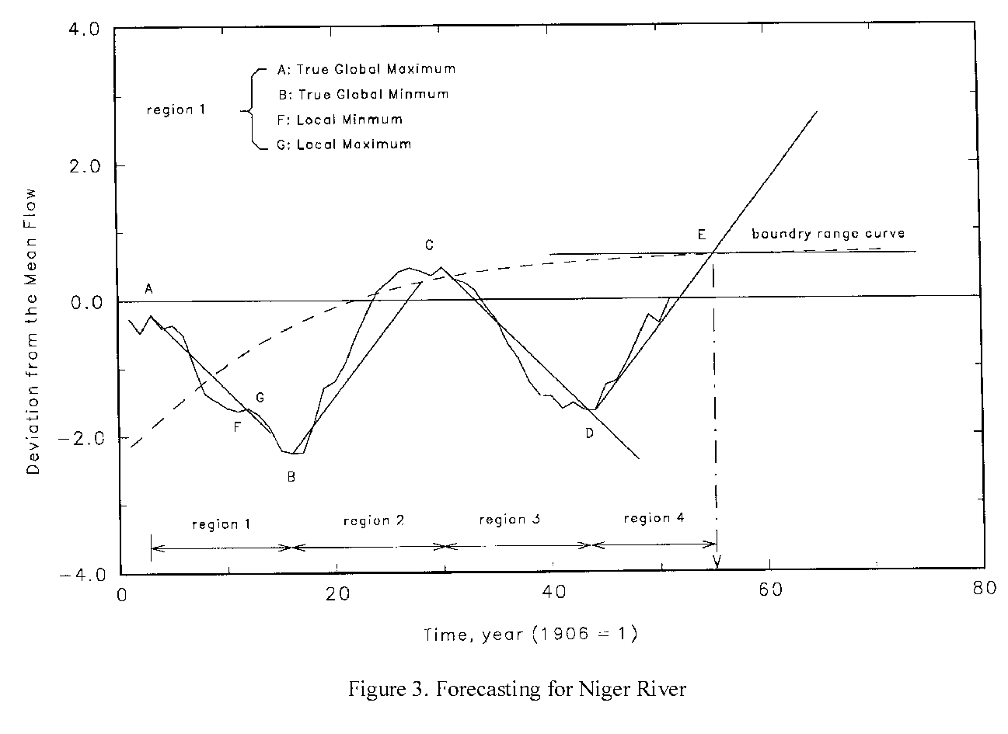
Recognition of the features of a realization curve are important to understanding the objective of the current study. The realization curve is composed of wet and dry periods, forming a long term cyclic pattern. These are evidenced by upward or downward trends in the realization curve. For example in Figure (3), there is a short term upward fluctuation from point F to G which is embedded in the long-term trend from A to B in region one of the curve. These long-term trends such as from A to B, B to C, and to D on figure (3) define major wet and dry periods upon which reservoir design must be based. Since reservoirs are designed to yield water over long periods, particularly during the course of multiyear drought periods. Therefore, prediction of such long term hydrologic trends on a realization curve is important.

As a result of the normalization process, every realization curve contains at least one minimum or one maximum global point (i.e., it has at least one half cycle if a full cycle incorporates wet-dry-wet-dry regions). For the Niger River as well as seven other rivers the realization curve reaches zero at least only after one full cycle (see the realization of figure 3). Reoccurrence of the next half cycle is expected to follow the continuation of the pattern. Sadeghipour and Dracup (1982) mentioned that drought events in a homogeneous region usually occur at the same period for each stream; this is consistent with the cyclic behavior of the realization pattern.

References
M. Adibi 1992. Anticipatory Conservation Based Drought Management of Water Supply reservoir. Ph.D. dissertation, S.M.U. press.

