Rainfall Harvesting for Indigenous Health in Australia

Carol Conway, Charles Nicholson (White Rocks Computing, Jimboomba, Australia), Gabriele Bammer (National Centre for Epidemiology and Population Health, Australian National University, Canberra, Australia), Alan Wade (ACTEW, Canberra, Australia), Graham Henderson (Australian Institute of Aboriginal and Torres Strait Islander Studies, Canberra, Australia)
Cooperative Research Centre for Water Quality and Treatment, Australia
Australian Institute of Aboriginal and Torres Strait Islander Studies, Canberra, Australia
E-mail: carol@elc.aiatsis.gov.au

Abstract

Australia is a dry country, particularly in the inland areas. The poor quantity and quality of water available to many Indigenous Australians living in rural and remote locations contributes to their poor health status relative to other Australians. Rainfall harvesting from the roofs of houses and buildings in Indigenous communities can provide a valuable source of potable water, but this harvesting is often inefficient. We report a study of two remote and diverse locations in areas where Indigenous Australians have water supply problems. The first is Giles in central Australia (25.04⁰S, 128.29⁰E) with a median annual rainfall of 119mm, and the second is Thursday Island in the Torres Strait (10.35⁰S, 142.22⁰E) with a median annual rainfall of 1718mm. We describe a means of correlating rainfall records with collecting roof areas, water storage capacity, house occupancy rates, and water consumption rates using a computer program. We determine the optimum match between these factors and the total collectable rainfall for the best, worst, and median years based on historical rainfall records for each location. This quantitative approach to rainfall harvesting could significantly improve the security of potable water supplies for many Indigenous communities in Australia, and thus contribute towards an improvement in Indigenous health.

Introduction

Australia is a dry country with limited water resources. Whilst there is considerable spatial and temporal variation in the hydrological characteristics of Australia, overall, rainfall and surface runoff is low and variable, evapotranspiration is high, and groundwater recharge is low (Smith 1998). Figure 1 shows the average annual rainfall and open-water evapotranspiration for Australia.
The Australian population (18.3 million in 1996) is concentrated in urban areas in the wetter parts of the country. Forty-seven per cent of the population lived in the wettest 10% (>881mm average annual rainfall) and 0.1% lived in the driest 10% (<186mm average annual rainfall) of the country in 1991 (ABS 1996). The Indigenous population of Australia (comprising 2.1% of the total population in 1996) has a different demography compared to that of the total population, with a higher proportion (69.7%) living in smaller urban, rural and remote locations than the total population (37.3%) (ABS 1998a). More than 10% of the Indigenous population lived in the driest half of Australia (<303mm average annual rainfall) in 1991 compared with less than 2% of the total population (ABS 1996).
The health status of Indigenous Australians is poor, with a life expectancy at birth 18-19 years less than other Australians (AIHW 1998). Poor living conditions, including poor water supplies in rural and remote areas, contribute to this health inequality (FRDC 1994; ABS & AIHW 1997).
Mains/town water was the predominant water source for 93% of households across Australia in 1998, with only 17% of households using rainwater tanks, and 5% using bores or wells as one of their sources of water (ABS 1998b). Bore water is the main source of water for Indigenous Australians in rural and remote communities, with rainwater tanks ranking second in importance (Hearn et al 1993). The quality of this bore water is often poor and may also be detrimental to Indigenous health (NHMRC & ARMCANZ 1996; Hostetler et al 1998).
The objective of our study is to improve the efficiency of rainwater harvesting in Indigenous communities so that rainwater tanks can provide a more reliable source of potable water and thus help alleviate the overall problem of poor water supplies in many locations. Importantly, this has required close and ongoing consultation with communities in a number of locations.

Figure 1 Average annual rainfall and open-water evapotranspiration for Australia*

(a) Rainfall
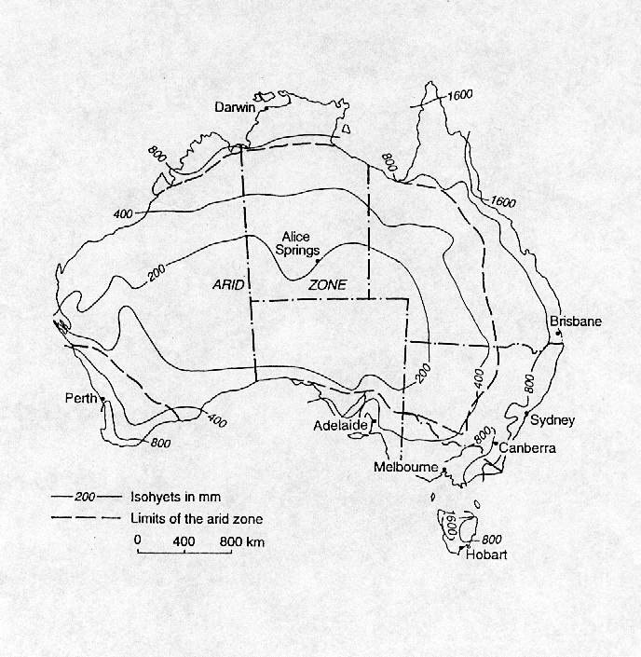
Thursday Island
Giles

(b) Evapotranspiration
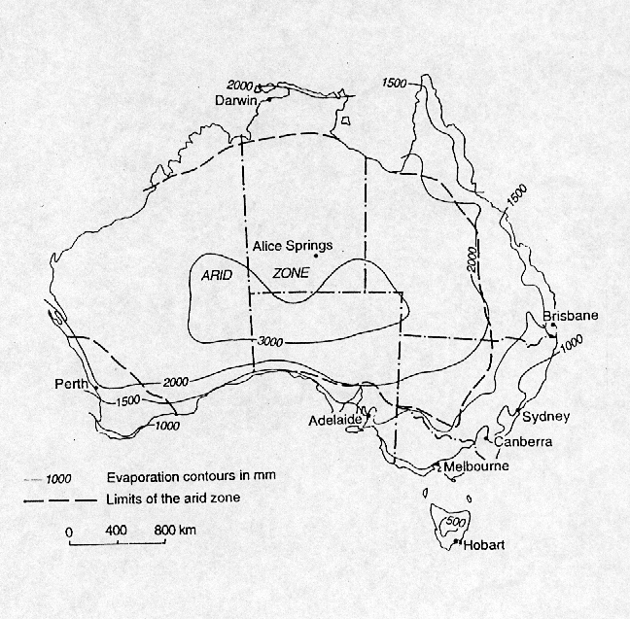

* Source: Smith (1998). Reproduced with permission of the author. The study locations Thursday Island and Giles are shown in Figure 1a.

Methods
For this study we used two widely different geographical locations with extended historical rainfall records. Chosen rainfall regions (refer to Figure 1a) are occupied by Indigenous communities. Giles (25.04⁰S, 128.29⁰E, height above sea level 598 m, rainfall record 42 complete years, from 1.1.1957 to 31.12.98) is a small government meteorological station located in an arid area of central Australia with a median annual rainfall of 119 mm. Thursday Island (10.35⁰S, 142.22⁰E, height above sea level 8.0 & 57.6 m [two rainfall recording stations], rainfall record 84 complete years [1.1.1906 to 31.12.1957 and 1.1.1993 to 31.12.1995 for station 1 and 1.1.1958 to 31.12.1992 for station 2) is a small town located in tropical northern Australia with a median annual rainfall of 1718 mm. Historical rainfall data was provided by the National Climate Centre, Bureau of Meteorology, Melbourne. Figure 2 shows some general features of the climate in both locations.

Figure 2 Median monthly rainfall, temperature, and relative humidity for Giles and
Thursday Island*

(a) Giles

(b) Thursday Island

- Source of data: National Climate Centre, Bureau of Meteorology, Melbourne, 1999. Relative humidity and temperature were recorded at 3 pm.

The roof areas, tank sizes, and house occupancy rates used in this study are based on data from Indigenous communities in the two regions. All roof catchments are corrugated sheet metal. We received permission from Nganampa Health Council and the Torres Strait & Northern Peninsula Area District Health Council to use this information in our paper.
We employed a modified version of the CSIRO RAINCATCH program to model tank water balance (Wall & McCown 1989). Rainfall data was entered, checked for its integrity, and years with incomplete data were discarded. No adjustment was made for runoff coefficients less than one, described by Pacey & Cullis (1986), but this could be factored in as a later refinement were this to significantly affect prediction of supply reliability.
It is important to point out that there are many important health factors related to the use and maintenance of rainwater tanks. However, although these have been noted (Cunliffe 1998, SAHC 1995), these factors are not discussed: time and resource restraints prevented their incorporation into the scope of this study.

Results
The graphs show: the total collectable rainfall per year as a function of roof area (Figure 3); and two case scenarios of roof size, house occupancy rate, tank capacity and water consumption for each location using the Raincatch computer program (Figure 4(a) and (b)). These case scenarios were chosen in order to represent a situation typical of each region.

Figure 3 Computer analysis of total collectable rainfall per year (kilolitres) as a function of roof area in Giles and Thursday Island for the best, median, and worst rainfall years

Figure 4 Computer analysis of rainfall harvesting for domestic water supply as a function of roof area, tank storage capacity, house occupancy, and consumption rate in Giles and Thursday Island

(a) Giles – 266 m² roof area, 27 kl tank storage capacity, and ten persons using 10 litres/person/day

(b) Thursday Island – 200 m² roof area, 22 kl tank storage capacity, and six persons using 50 litres/person/day

Discussion
The arid and central areas of Australia are often labelled as dry and with insignificant rainfall. In the past this has influenced decisions such as the chosen capacity for installed rainwater tanks, if their installation were even considered. However, Figure 3 shows that, even in arid locations such as Giles, roofed areas have the potential to collect significant amounts of rainwater. A 250 m² Giles house for instance can be used to collect 61.25 kl (61,250 l) in a median rainfall year. This can provide 10 people can be provided with 16.78 l of water per person every day. The case is even more significant for Thursday Island where in a median year the same size roof could potentially collect 431.23 kl (431,230 l) of rainwater, resulting in a supply of 118 l per person per day.
In Figure 4, the importance of correlating roof area to tank storage size and consumption rate is illustrated. Considering 4(a) [Giles], a house with a 266 m² roof could provide 10 people with 10 litres of rainwater per person per day even in the worst year on record, providing a tank with a capacity of 27 kl was utilised. However, even in a median rainfall year in can be seen that overflow results from a 27 kl storage tank, suggesting that for this house occupancy and consumption rate, a larger tank size would be more beneficial.
The situation for a tropical Thursday Island is shown in Figure 4(b). A consumption rate of 50 litres of rainwater per person per day was used to account for the comparatively larger rainfall. Only during the best years on record is this water consumption rate sustainable for a 200 m² roofed house linked to a 22 kl rainwater tank. It can be also seen from Figure 4(b) that, using this size tank, a large amount of overflow results between the months of January and April, and so it seems a much larger collection tank would better utilised in this area.

Conclusion
A significant amount of rainwater can be harvested even in the most arid regions of Australia. It can be used as a reliable source of potable water or as a valuable water supplement in many cases. Rainwater harvesting can be better optimised using computer analysis programs such as Raincatch. The importance of correctly matching historical rainfall, roof size, house occupancy with water consumption rates has been illustrated. In comparison, guess work may result in the loss of valuable potable water resources (tank overflow), an unreliable rainwater supply for part of the year (empty tank), or an over allocation of scant resources arising from oversizing of tank systems.

References

ABS (Australian Bureau of Statistics) 1996, Australians and the Environment, Cat. no. 4601.0, ABS, Canberra.

ABS (Australian Bureau of Statistics) 1998a, Census of population and housing: Aboriginal and Torres Strait Islander people, Australia, Cat. no.2034.0, ABS, Canberra.

ABS (Australian Bureau of Statistics) 1998b, Environmental Issues: People’s Views and Practices, Cat. no.4602.0, ABS, Canberra.

ABS (Australian Bureau of Statistics) 1998b, Census of population and housing: Aboriginal and Torres Strait Islander people, Australia, Cat. no.2034.0, ABS, Canberra.

ABS & AIHW (Australian Bureau of Statistics & Australian Institute of Health & Welfare) 1997, The health and welfare of Australia’s Aboriginal and Torres Strait Islander peoples, Cat. no. 4704.0, ABS, Canberra.

AIHW (Australian Institute of Health & Welfare) 1988, Australia’s health 1998: the sixth biennial report of the Australian Institute of Health and Welfare, AGPS, Canberra.

Cunliffe, D. 1998, Guidance on the use of rainwater tanks, Water Series No.3 South Australian Health Commission, National Environmental Health Forum, Adelaide
FRDC (Federal Race Discrimination Commissioner, Human Rights and Equal Opportunity Commission) 1994, Water: A report on the provision of water and sanitation in remote Aboriginal and Torres Strait Islander communities, AGPS, Canberra.

Hearn, B., Henderson, G., Houston, S., Wade, A. & Walker, B. 1993, ‘Water supply and Aboriginal and Torres Strait Islander health: an overview’, AGSO Journal of Australian Geology & Geophysics, 14 (2/3), 135-146.

Hostetler, S., Wischusen, J. & Jacobson, G. 1998, Western Water Study (Wiluraratja Kapi): Groundwater quality in the Papunya – Kintore region, Northern Territory, Record 1998/17, AGSO, Canberra.

NHMRC & ARMCANZ (National Health and Medical Research Council & Agriculture and Resource Management Council of Australia and New Zealand) 1996, Australian Drinking Water Guidelines 1996, AGPS, Canberra.

Pacey, A & Cullis 1986, Rainwater harvesting: The collection of rainfall and runoff in rural areas, Intermediate Technology Publications, London.

SAHC (South Australian Health Commission) 1995, Guidelines on the collection, care and control of rainwater in tanks, Public and Environmental Health Council, Adelaide.

Smith, D. I. 1998, Water in Australia: Resources and Management, Oxford University Press, Melbourne.

Wall, B. H. & McCown, R. L. 1989, ‘Designing roof catchment water supply systems using water budgeting methods’, International Journal of Water Resources Development, 5, 11-18.

Indigenous refers to Aboriginal and Torres Strait Islander people.

