Rainwater Catchment in Brazil’s Rural Semiarid Tropics: A Grassroots' Approach

Johann Gnadlinger
Caixa Postal 21
48900-000 Juazeiro, Bahia, Brazil
Tel: 0055-74-811-6481
Fax: 0055-74-811-5385
Email: ircsa@netcap.com.br

Abstract
During the past decade, NGOs and grass-root organizations working in Brazil's semiarid tropics have focused on rainwater catchment systems as an essential contribution to people's survival under the region's climatic conditions. Awareness about the possibilities of the semi-arid region had to be raised. The main necessities are adequate education at all levels, therefore organizations working in the Northeast dedicate most of their efforts on this aspect. The organizations not only teach appropriate technologies, but first speak about an appropriate understanding of the semiarid climate and than introduce rainwater catchment systems and look at the socio-economic and cultural conditions of the people involved. There has to be a political willingness to create an infra-structure such as access to land, animal raising, rain-fed agriculture, water supply, education, health service, streets and commercialization of local products. Once these aspects are taken into consideration, the future of the rural population in the Brazilian semiarid region will be more certain.

Introduction
The semi-arid tropics or so-called "drought stricken polygon" in Brazil's Northeast is a region extending over about one million square kilometers and peopled by about 15 million inhabitants. Every couple of years the rural population is faced with a drought and not able to cope with it. Each year the people till the soil and plant corn hoping for sufficient rainfall. But regular and sufficient precipitation is the exception rather than the rule in a semiarid climate. Thus a bad harvest seems to be programmed in advance..

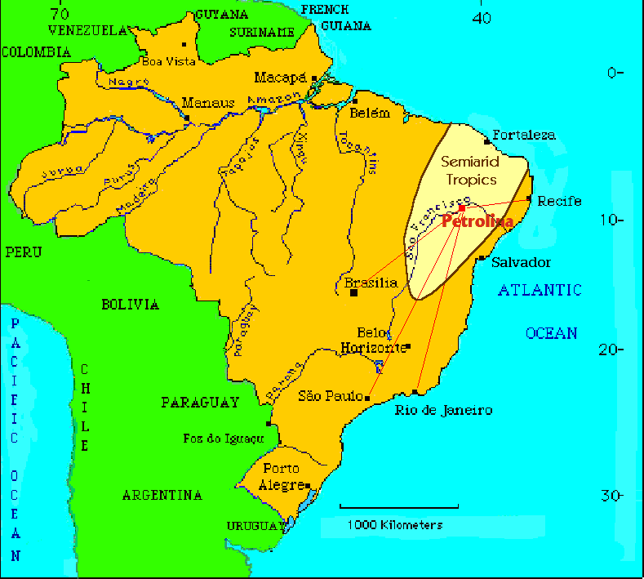

Map of Brazil showing the semi-arid tropics or dry polygon in the Northeast.

For most politicians - from the simple county counselor to congress representatives - dry years mean a guaranteed election victory. State funds are being manipulated as election baits and water trucks for the thirsty cows catch the votes of a whole village. The rich flow of funds from the capital Brasilia is not channeled to the needy people but ends up in the hands of corrupt politicians. The so-called "labor front against the drought" and well digging programs are being used by big landowners for their own benefit. The politicians earn lots of money with each drought and therefore they have no interest in taking preventive measures for the next draught period.

History
Between 1981 and 1983 the area was once again drought stricken. Vast parts of northeastern Brazil were affected and the people were completely unprepared. The Brazilian government had received previous information about the coming drought from meteorologists. However, this information did not reach the people. As a result, many migrated to the big cities, others were forced to sell their land to big landowners and irrigation farmers for a ridiculous price.

For the people affected it seemed like an organized attempt at genocide. Those strong enough to organize and resist, got together to develop strategies of dealing with the politics of drought. "No Nordeste não falta água, falta justiça!" ("In Brazil's Northeast there is no lack of water, there is a lack of justice!"), was one the main slogans of that time.

Some people working with NGOs, grass-root organizations and communities realized that besides the importance of a land reform and political organizing, there was also the need to develop a well-structured education program for peasants. At the beginning there were only some isolated experiences centered around communal water management, communal fields, manioc mills, bee keeping, communal tractors, bore wells, deposits for water from rainfalls, avoiding slash and burn farming, refusing chemical pesticides, etc.

Later on, three main topics were developed geared at guaranteeing the peoples’ survival in Brazil’s Northeast:
- Climate and water management: How does the semiarid climate work and what consequences does it have for agriculture. Establish preventive measures such as rainwater catchment in order to have water reserves for the dry periods.
- Animal husbandry: Keeping small animals, especially sheep and goats, adapted to the semiarid climate; provision of fodder for the dry months, de-worming, etc.
- Dry land farming: harvesting in years with poor rainfalls; which plants are best suited for a semiarid climate.
IRPAA (Regional Institute for Appropriate Smallholder Farming and Animal Husbandry) is focusing on these above mentioned topics. Founded in 1990, it is an independent non-governmental organization with headquarters in Juazeiro (Bahia) the twin city of Petrolina (Pernambuco). Today, there are a number of other similar rural projects underway in various regions of the Northeast.

Methodology
Concerning IRPAA's methodology we tried to find a balance between theory and practice. Our job is not only technical assistance but mostly educational work, spreading knowledge through practical examples. A specific technology can never be followed blindly. It is assumed that peasants and sheep and goat breeders have been applying technologies that worked well for them. These technologies have allowed the small farmers to survive in Brazil's Northeast. Once these technologies are combined with new knowledge they are the foundation for an "appropriate" technology, enabling the rural population to live in an arid climate zone. Regarding rainwater catchment systems, we do not prescribe the kind of cistern to be built and used, but we guide and supervise people in discovering the rainwater catchment system most appropriate for their case.

Rainwater catchment adapted to specific climatic conditions
Due to the draughts occurring every couple of years, the Brazilian Northeast is often called an emergency zone. We think that this so-called emergency is man-made. If we find a way of living under these climatic conditions, then we do not need to blame "draught spells" for causing our problems.
One can change a lot, but certainly not the amount of rainfall and its distribution. We must find a way of life, a way of farming and animal husbandry that agrees with the precipitation and the type of soil. It is of no use to complain about lacking rain. For thousands of years the Northeast has known droughts and they will continue to occur for many thousand years to come.
How can we change our attitude concerning water?
In the Northeast it rains a lot. But we are careless about this gift. In the rainy season we let the water run off and some months later we have to beg the local politicians to send us water trucks.
Therefore we must build reservoirs to collect rainwater. In the first place we must calculate how much water we will need during the dry months. For example one person needs at least 14 liters of water per day, one cow 53 liters and a goat needs 6 liters a day.
We need a rainwater cistern for drinking water close to each house, a bigger pool for rainwater storage - at least 3 meters deep (because of high evaporation) - for each community for water used for washing as well as the animals and thirdly, an additional year round water source easily accessible for several communities. The latter could be a small but deep rainwater reservoir or a deep well.
These three types of water supply are called:
- family water
- community water
- water for emergencies.
We can get water from the subsoil, from rivers or from rainwater catchment. The subsoil in almost half of the semiarid region is crystalline rock. Therefor there is no suitable aquifer in this type of subsoil, because water is found only in fissures and often salty. Only near the São Francisco River and a few other perennial rivers do we have an adequate supply of piped water and irrigation. Rainwater catchment, on the other hand, is viable in every part of the semiarid region and the most appropriate solution for the area with crystalline subsoil.

At the beginning of the eighties, the farmers in the Casa Nova (Bahia) county (on the left side of the São Francisco River) were hit by a severe draught. Some people from the county remembered that in former days people used to dig "caxios" in order to collect rainwater. Caxios are rock cisterns, i. e. deep, narrow holes dug into the softer rock. People got together and started to dig. The local politicians, belonging to the old ruling families, made fun of them threatening them, "You may well die of thirst while working together. We are not going to send you a single water truck!"
The months went by and there was hardly any rain, but the people did not suffer from any water shortage as their "caxios" had filled up. And even today the people tell that those who had trusted the local politicians and their water trucks "had died of thirst".
Even in the dry years of 1993, 1995 and 1998 the "caxios" had enough water for humans and animals all year round.
It only makes sense to dig deep reservoirs with a small surface otherwise they will be dried out by the wind and the sun.

In the region around the cities of Canudos and Campo Alegre de Lourdes (in Bahia) the communities started to collect rainwater from the roofs. They built cisterns of 15,000 l near their homes where water is collected in the gutters and brought to the cisterns. These cisterns are sealed on top to avoid evaporation and to keep out insects. To have an all year water supply, one needs to know one’s water needs and the size of one’s roof. With this in mind, one can build the right size cistern. The cistern must be round to avoid cracks. It can be made of concrete plates, iron cement or local materials such as bricks and lime mortar.

What do we have to change in regards to goats and sheep?
In 1993, a drought causing El Niño year, the people of Cipó village (Juazeiro County) gathered to discuss the scarcity of rain. They realized that there was hardly anything to harvest in the fields. However, the people were not discouraged, although they knew that the sheep and especially the cows would have to struggle to survive until the next rainy season. The goats posed no problem. They were healthy and had a shiny skin. In the natural thornbush vegetation goats find enough fodder and way into the dry season they would be eating the husks from the Prosopis tree and the leaves of the Opuntia cactus. This cactus is not only important as fodder for the goats, but supplies them with water. (In their trunks and leaves cacti store rainwater). Neither would people be lacking water. Along the temporary river beds they had dug shallow wells and lined them with stones.
In Jaboticaba village (Bahia) the people had planted enough draught-resistant buffalo grass for hey. In 1998, another El Niño year, people were prepared in terms of their water supplies and had stored enough fodder for the animals. One of the small farmers said: "In the past, we only thought about planting the fields without knowing whether we would harvest or not. At the time when our animals need special care we neglected them although they are our main source of income."
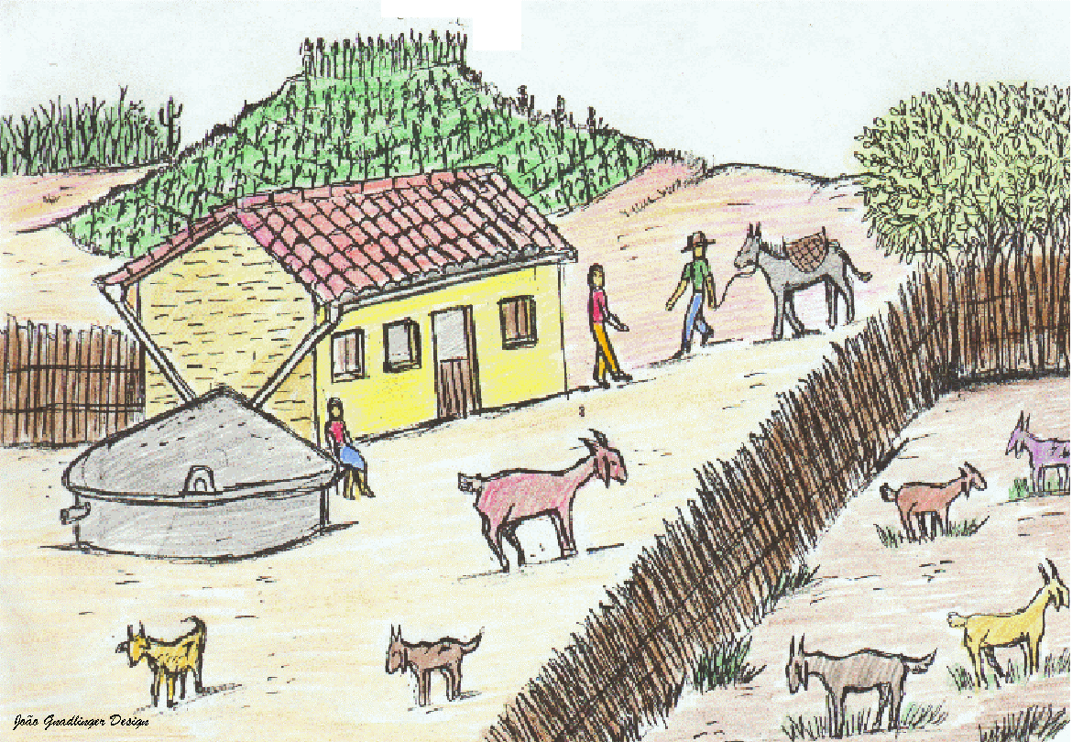
Smallholder farm in Northeast Brazil

What do we have to change in terms of planting?
In good years, that is years with enough rain, the farmers can even have an additional income from their harvests. But what to do to make plants survive between rains? Without regular rainfall, farmers must find methods to avoid evaporation of the soil:
- Most important, slash and burn clearing has to be stopped. Whenever farmers go out into their fields the matchbox has to stay at home. Straw and the dry leaves on the ground collect rainwater and protect the soil from the sun and loss due to evaporation. As time goes by, they rot and turn into layers of humus.
- Animals are also of great importance, since they produce manure, which can be used in the fields. The mixture of aged manure with soil is not only a good fertilizer, but more important in arid regions - it holds back humidity. Since manure collects rainwater it is the most important water reservoir for crops!
There are other rules to follow if farmers want to get a better crop. For instance, they should choose plants capable of resisting long dry periods. In many arid places sorghum is planted, rather than corn, which is still popular even in Brazil's semiarid region. Sorghum is better adapted to the semi-arid climate and yielding much more.
It is also important to plant in leveled furrows (ridge cultivation), thus avoiding soil erosion. The furrows collect runoff water and bring it to the roots of the plants.
The farmers following these rules while planting smaller plots, will harvest the same amount as they harvested with bigger fields, with the only difference, that harvest is almost guaranteed.

Women and Rainwater Harvesting
It is the women who suffer the most during draughts. They fetch the water from the nearest wells, carrying the containers on their heads. They are always trying to find ways to feed their large families. During dry years, the women make survival of their families possible. They keep a few chickens for eggs, one or two pigs are being fed with the leftovers, they use a small plot to plant vegetables, preferably near the water reservoir and watering it with a small can.
After the girls from Cicero Dantas County had received training on water supply, they demand from their future husbands to build water cisterns near their houses in order to spare their wives the daily fetching of water. The solution of water supply during the dry season makes women's daily lives much easier. Instead of spending lots of time fetching water, women and girls can use this time to plant vegetables, to work in the community or to get further education. "The cisterns are liberating us women from the daily water fetching. At the same time they liberate our community from its dependency on the water trucks sent by our politicians", said Dalva from a village in Uauá County (Bahia).

Examples showing the practical results of this holistic approach
Alcides, a small farmer from the city of Uauá (Bahia), who used to raise goats and plant corn was about ready to migrate to São Paulo, the 2000 km distant economic capital of Brazil. Nearly half the village had moved to São Paulo in the course of the past thirty years. It was mostly men who left, while women stayed behind with their children. Many people, especially the young, are dreaming of life in the city, preferring it to work on the farm. Right at that time, Alcides’ brother convinced him to participate in a course on appropriate life in an arid region.

Alcides was so enthusiastic about this course that he gave up on the idea of migrating to São Paulo. Instead he became one of the most active defenders of life in the Northeast. He built a big cistern near his home. Before the last rainy season, he marked the contour level and plowed a half acre ridge, where he planted sorghum and beans. The rain no longer washed away the soil and the water was held back in the horizontal furrows. This way of cultivating the soil prevents erosion. Next year, Alcides will be able to plant the same plot without having to burn the natural thornbush vegetation. His neighbors will follow his example.

Teachers who had participated in courses on appropriate technology in the Northeast, became aware that the books used in schools were about life in the cities in Southern Brazil and didn't reflect the reality of the rural Northeast. They thought that books should be changed according to the needs of the rural population. Thus children would not be educated for city life, but rather be prepared for life in the country side. In the county of Curaça (Bahia), the first rural communities to receive this training, primary school teachers are being instructed to make teaching about life adapted to the semiarid climate part of their curriculum. Teaching mathematics, children no longer take the examples from urban surrounding, but they calculate the amount of rainwater falling on a roof and are asked to figure out if it will be enough to supply their families with water for the dry season, given a certain water consumption. In other schools the project led to the introduction of a new curriculum for fifth to eighth grade and new teaching aids have been produced.

Evaluation and outlook
Until now there hasn't been a political will to change the situation of the people in the semiarid zones of Brazil. Normally the politicians representing the interests of the big landowners want to control the access to water sources. They have no interest in people taking their own destiny in hands. There are a handful of politicians - mostly from the opposition - who have taken an interest in learning about alternatives.

The governmental rural extension services have been mostly at the service of the big landowners and irrigation farmers. But there are some hopeful exceptions: The official Agricultural Research Center for the Semiarid Tropics (CPATSA) from the Brazilian Agricultural Research Agency (EMBRAPA) has been working with appropriate technology in rainwater catchment systems for years. For this center our experience with imparting basic knowledge among the rural people in the Northeast is important for spreading these technologies.

Usually there are no public funds for small farmers to receive further training nor is there money for projects to build cisterns on a large scale. But there are a few exemptions: In counties like Curaçá, one per cent of the local budget is used for constructing cisterns and shallow wells. In other counties, politically organized people are trying to change the local laws to guarantee the whole rural population's water supply with cisterns by the year 2005. In other villages, families received loans from aid agencies for building cisterns and paid back their loans by selling goats. This money was put in a communal fund, which was used for building more cisterns. This way thousands of cisterns were built.

There are also a number of similar rural projects like IRPAA underway in various regions of the Northeast. Some NGOs, labor unions and smallholder associations joined to a network called "mutirão" ("neighborhood help") and have taken up the same methodology, cooperating directly with small farmers, including such topics as rainwater supply and climatic conditions. All these projects have started to cooperate more closely with each other in order to work out a common strategy and program. Labor unions in some counties have made the struggle against the rural exodus part of their demands, various communities are elaborating plans to supply rural people and animals with water during the dry season. Such different organizations as UNICEF, Charities of Brazil and other church affiliated groups are engaged in these projects. A pilot project, which includes water supply, animal raising, rain-fed agriculture, commercialization, education among the rural population is planned in three counties of Northern Bahia – Curaçá, Uauá and Canudos. The positive results of this work have been an encouragement to many people in Northeast Brazil.

Families living in isolated areas with no access to an organized community might not be able to resist migration to the cities or finding employment as cheap labor in irrigation projects. On the other hand, rural people organized in grass-root communities who know about the semiarid climate and appropriate production methods will be ready to fight for just rainwater catchment systems as well as for all the other aspects facilitating and enriching life in the Northeast. Looking at the extension of the Northeast makes one realize that there is still an immense task ahead. Certainly the experiences of other countries presented at the 9th IRCS Conference will encourage us to continue on this path.

