Underground Temperature Survey for Detection of Groundwater Vein-Stream and Flowing Layer in Dry Area

Atsuo Takeuchi, Gen Furuya
Disaster Prevention Research Institute
Kyoto University, Gokasho Uji-city Kyoto Pref.Japan,611-0011
E-mail: takeuchi@landslide.dpri.kyoto-u.ac.jp

Abstract

It is known that rainwater infiltrating into soil tends to drop infiltrating velocity to the vertical direction and tends to flow horizontally when it reaches an unpermeable layer. Therefore it is necessary to determine exactly the location and depth of the groundwater vein stream flowing above the unpermeable layer for effectively using groundwater.

In order to accomplish this, an electric resistivity survey and an electric logging have been carried out. The information on the location of the groundwater is obtained by these methods. It is very difficult though to obtain information on the location and depth of flowing groundwater in vein streams.

The authors developed an underground temperature survey method to detect the accurate information on groundwater vein stream. This method uses the difference between temperature of flowing groundwater and ground temperature of a shallow layer. It is composed of a one-meter-depth temperature survey, a multiple point's temperature logging and/or usual temperature logging, and a flowing direction and a velocity measurement.

The groundwater investigation method utilizing temperature is extensively used for research of groundwater vein-streams in landslide areas, underflows, groundwater disasters, groundwater obstructions and groundwater resources.

Introduction

It is recognized that rainwater infiltrating into the soil tends to reduce infiltrating velocity in the vertical direction and tends to flow horizontally when it reaches an impermeable layer. It is necessary to determine exactly the location and depth of the groundwater vein stream flowing above the impermeable layer to make effective use of the groundwater.

In order to accomplish this objective, electric resistance survey and electric logging are carried out mainly for obtaining this information. The information on the distribution location of groundwater is obtained by these methods, but it is very difficult to obtain the information on the location and the depth of flowing groundwater vein streams. The authors developed an underground temperature survey method to detect accurate information on the groundwater vein stream. This method utilizes the difference between temperature of flowing groundwater and ground temperature of shallow layer. It is composed by one-meter-depth temperature survey, multiple points temperature logging and/or usual temperature logging, and flowing direction and velocity measurements. An example applying the above method in a sand-gravel area was presented for water resource. Very useful information on the location and depth of flowing groundwater vein streams were obtained. Initially, an outline on one-meter-depth temperature investigation method and multiple point temperature logging method are described in this paper, and next, the effectiveness of this method was explained on the basis of in situ investigation. The groundwater investigation method utilizing temperature is extensively utilized as a method on the research of groundwater vein-stream in landslide areas, underflow, groundwater disaster, groundwater obstruction, groundwater resource, etc. in Japan and in dry areas.

1 The investigation method on groundwater vein stream by one-meter-depth temperature:

1-1 Principle of the method
A green rich oasis in the arid desert region is formed around a spring which is an outcrop of groundwater vein stream. It forms a cooler region than the rest of the area. Even in the case of very hot ground surface where one cannot walk barefoot, one can walk near the spring point barefoot. The basic principle of the investigation method of groundwater vein stream by measuring underground temperature is similar to this phenomena. Based on this fact, it is suggested that we can detect the location of a groundwater vein stream by measuring ground temperature at shallow layer in soil.
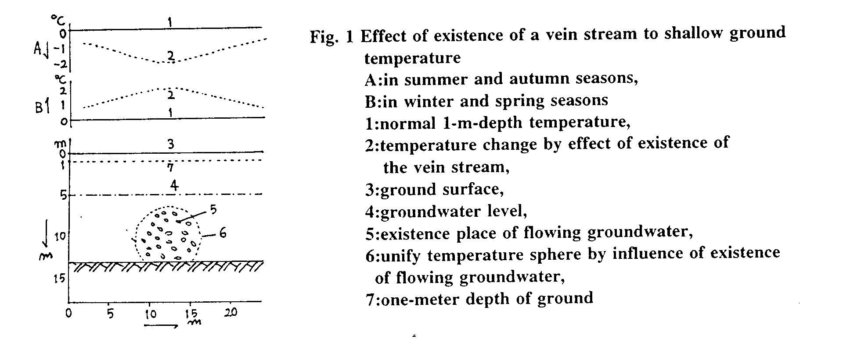
The principle of this method is very simple. In short, it identifies the normal distribution of temperature. A groundwater vein-stream exists in the normal distribution area (Fig. l). The temperature around the vein stream tends to be lower by the effect of the existence of the vein in summer and autumn seasons, because the temperature of the vein stream is lower than that of ground temperature without the vein stream (Fig. 1-A). On the other hand, the temperature of the vein stream is higher than that of ground temperature in winter and spring seasons, so that the temperature around the vein stream tends to be higher by the effect of the existence of the vein stream (Fig. 1-B).

1-2 Executing time for carrying out the investigation
This investigating method utilizes the difference of temperature between shallow part in the earth and flowing groundwater. Accordingly it is difficult to carry out this method when temperature is equal in the two areas. One-meter-depth temperature and that of a spring was measured for a long period of time at several investigating areas. This investigating method utilizes the difference of temperature between shallow part in the earth and flowing groundwater in situ to estimate the scale and the depth of a vein stream from the result of measurements of one-meter-depth temperature using the method of YUHARA (1955).
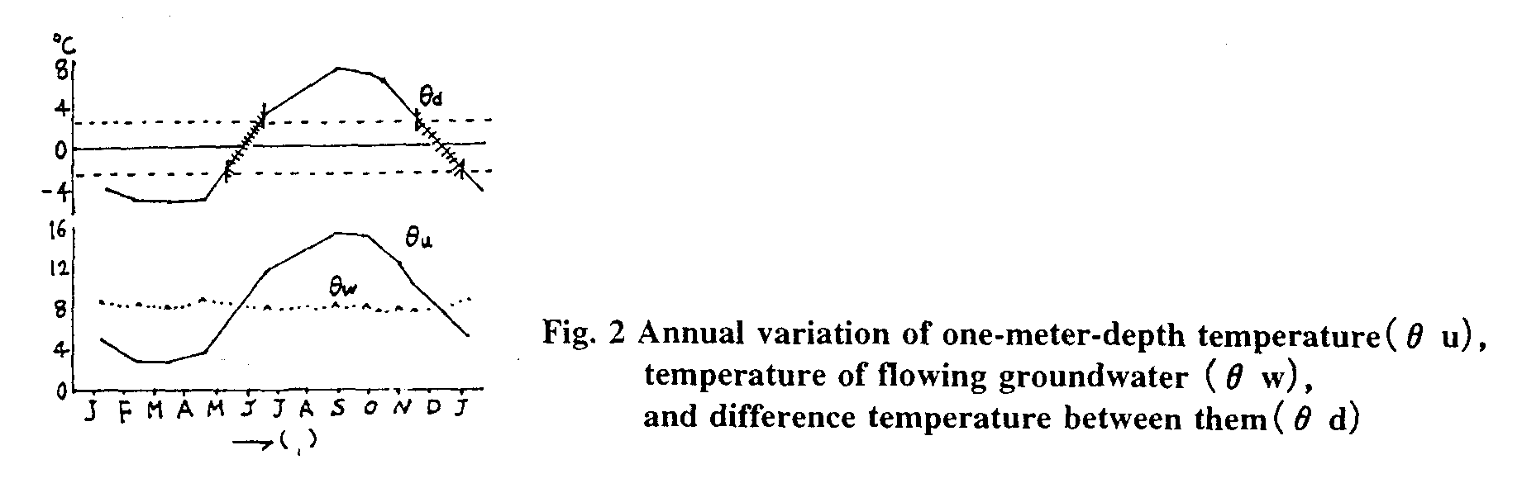
On the basis of this examination, the preferable season for carrying out the investigating method in Japan was in the coldest season with February as the central month, and in the hottest season with August as the central month. As the result of the investigation in foreign countries, it was shown that the preferable season in the temperate region such as Taiwan, China, and France was nearly equal to Japan and the season in the tropical region such as Indonesia was year round.

1-3 Arrangement of measuring line
In order to estimate accurately the flowing channel of the vein stream, suitable measuring line and/or mesh must be arranged. They are usually arranged on a topographical map having 1/1000 or 1/500 scale. The interval of measuring point is usually 10 m crossing the vein stream and 20 m parallel to that. In the case of investigating a very small vein stream, measuring points are arranged at smaller intervals than is usual, for example 5 m × 5m or 2m × 3m, etc. On the other hand, in the case of investigating a very large underflow channels, measuring points are set at larger intervals than is usual, for example 50 m × 100 m or 50 m × 50 m, etc.

1-4 Measuring method of one-meter-depth temperature
The results are recorded as follows:
1. The temperature is measured at a one-meter depth hole at a selected point.
2. Insert a thermometer carefully into the hole;
3. After 10 minutes, measure the temperature of the inserted thermometer;
4. Record the measured data in the field notes noting the measuring point number, temperature recorded by the thermometer, inserted and reading times, ground conditions around the measuring point, and memorandum for the point.
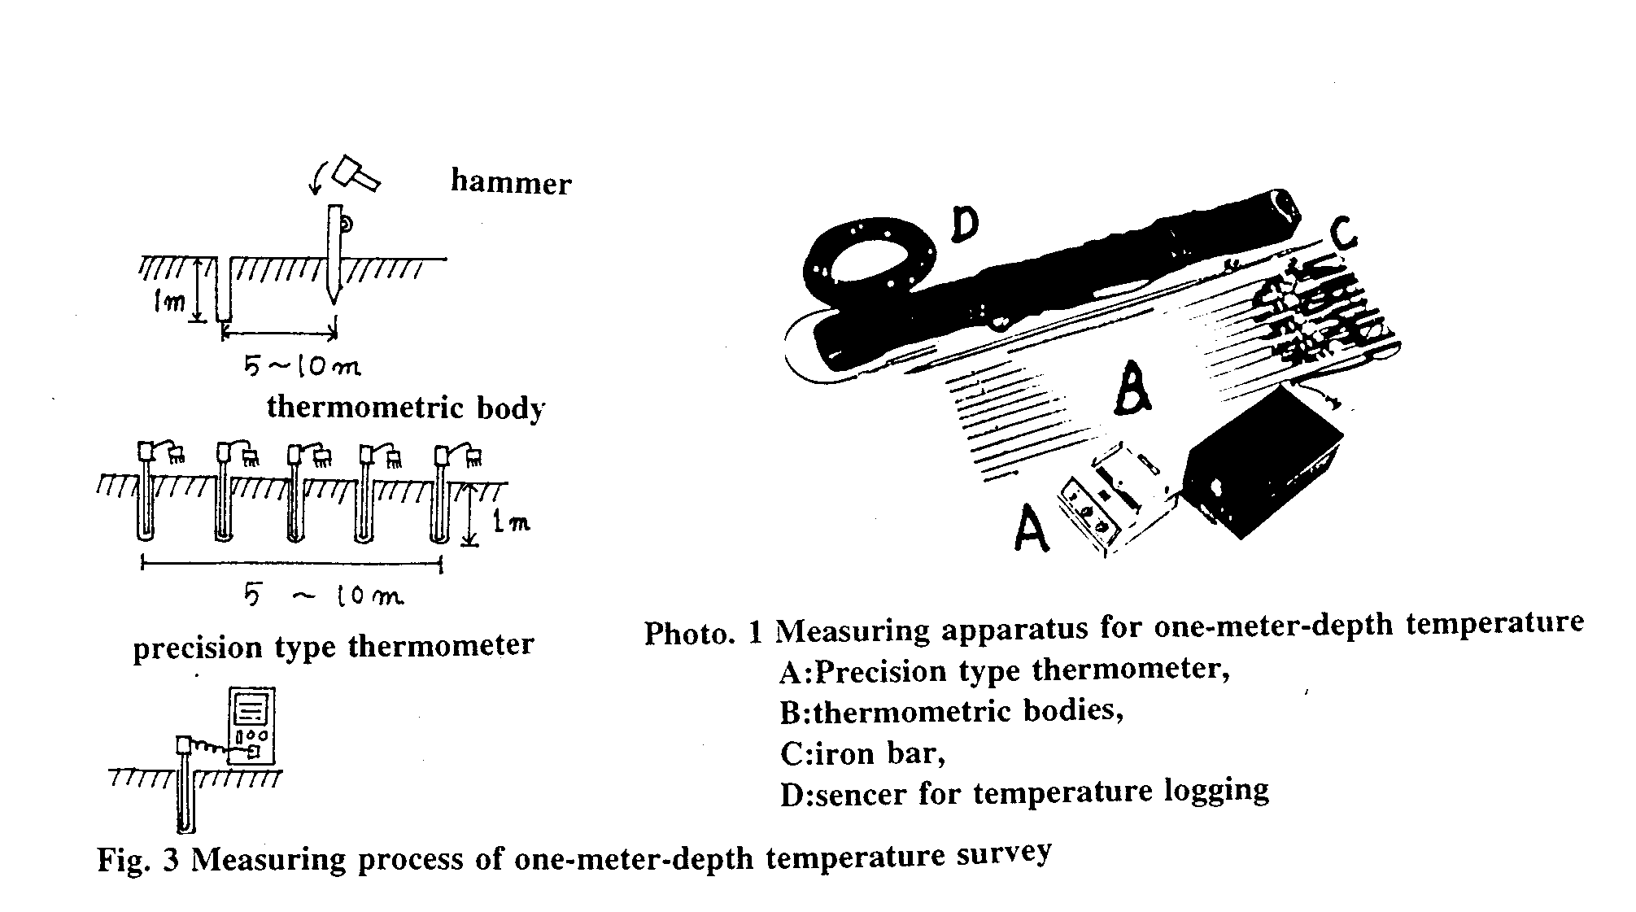
1-5 Method of analysis
Measured data is effected by various factors. So it is necessary to nullify the various factors to obtain accurate information on groundwater vein streams.

Some factors that influence the measured data is as follows:
A: Factors influencing measuring time:
1 Peculiar error of thermometers;
2 Temperature variation with various measured depths;
3 Annual variation of ground temperature during the measurement period.

B: Factors influencing the location:
1 Ground conditions around the measured point;
2 Topographical conditions at the measured point;
3 Geological conditions at the measured point.
The removal of and correction method of various influencing factors in measured values are described in the paper of TAKEUCHI(1980) in detail.

1-6 Methods of results interpretation and analysis
The interpretation method of the analyzing result is very simple. The result of analysis is interpreted after grasping the relationship between normal one-meter depth temperature and temperature of flowing groundwater in situ. In the case that the temperature of flowing groundwater is lower than normal one-meter depth temperature in the survey area, the location of vein streams is detected by lower temperature than in other sites (Fig.1-A). On the other hand, if the relationship is opposite, the temperature of existing place of vein streams is detected by higher temperatures than in other sites (Fig.1-B).

2 Multiple points temperature logging for detection of flowing groundwater

2-1 Principle of this method
When hot water is poured into a borehole, the temperature will decrease rapidly at the groundwater flowing layer, while it will decrease very slowly at other layers. Accordingly, we can obtain the information on the existing depth and thickness of groundwater flowing layer by utilizing this phenomena (Fig. 4).

2-2 Outline of this apparatus
The apparatus of multiple points temperature logging is composed of a sensor furnished with precision thermometers at intervals of 50 cm, measuring instruments, notebook type personal computer, batteries and temperature rising instrument in a borehole (Photo. 2).
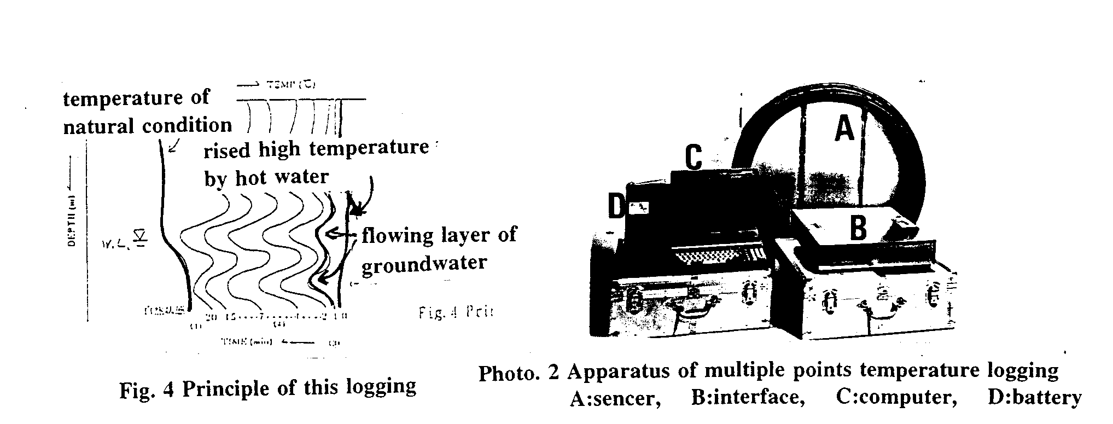
2-3 Measuring method
Temperature of air and water in a borehole rises as uniformly and as high as possible by pouring in hot water. After that, the temperature in a borehole is measured at intervals of one minute from one to seven minutes, at interval of 5 minutes from 10 to 30 minutes. The results of measurement are shown on the computer display at every measured time as temperature-depth curves(Fig. 5).
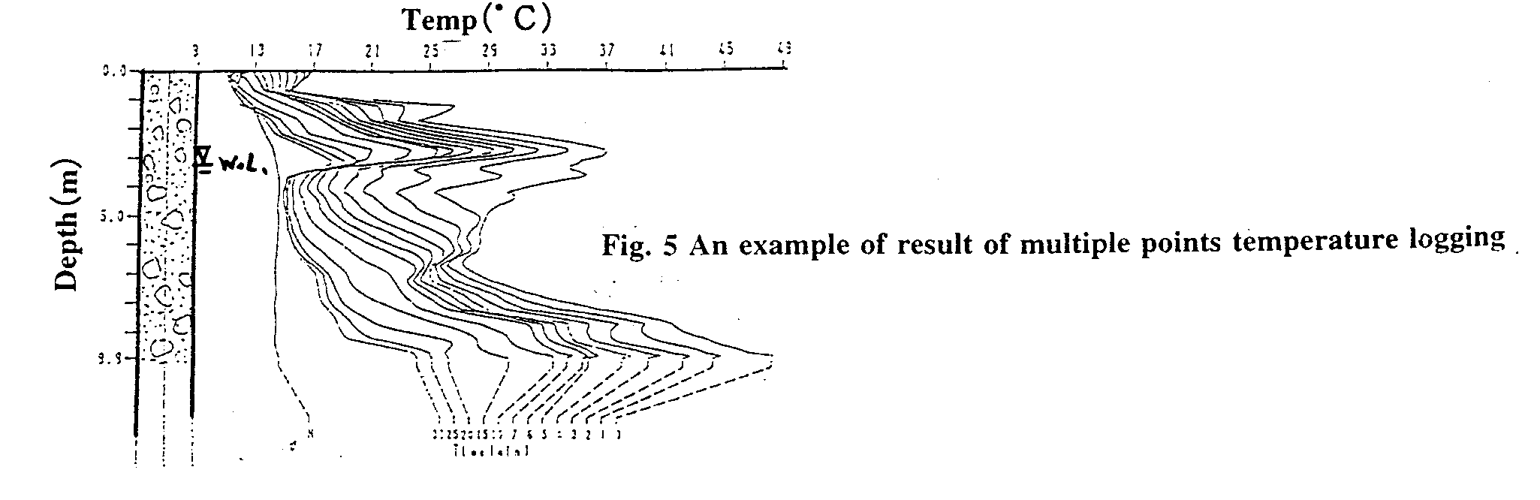
2-4 Interpretation of the results
The measurement values obtained in situ are expressed as temperature restore rate-depth curves. The flowing condition of groundwater is interpreted by using the curves.

3 An in situ example
One-meter-depth temperature survey and multiple-points temperature logging were carried out in a sand-gravel area to identify a water source for a large city. As a result, very useful information on the location and depth of flowing groundwater vein streams was obtained.

3-1 Introduction
The investigation area is located in a fan-shape field near a river. It consists of thick sand and gravel layers. In February 1997, a groundwater investigation with one-meter depth temperature measurement method was carried out here to choose a suitable position for a well that will supply water to the city.
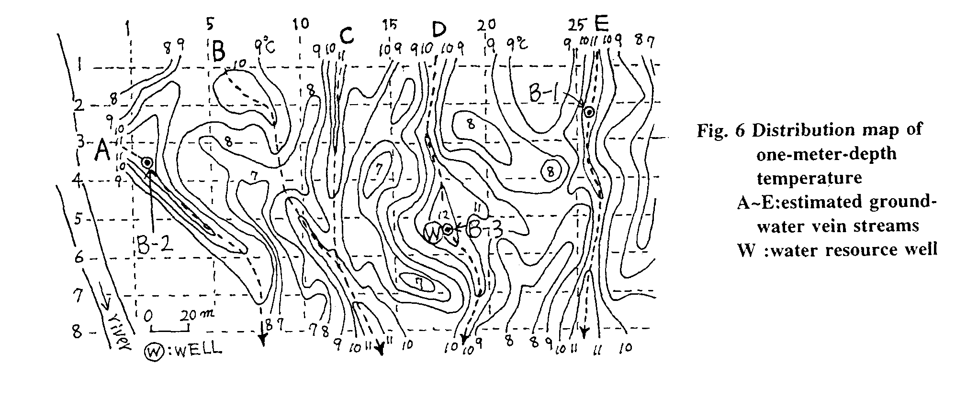
3-2 Investigation results of the ground temperature measurement method at one-meter depth
Fig. 6 shows the measurement net of the ground temperature measurement at one-meter depth. The mesh is 10 m× 20 m. The correction of temperature vector, day deterioration and ground condition have been carried out on the in situ data. From the above, it could be estimated that some groundwater veins exist in the investigating area (dotted line: A~E).
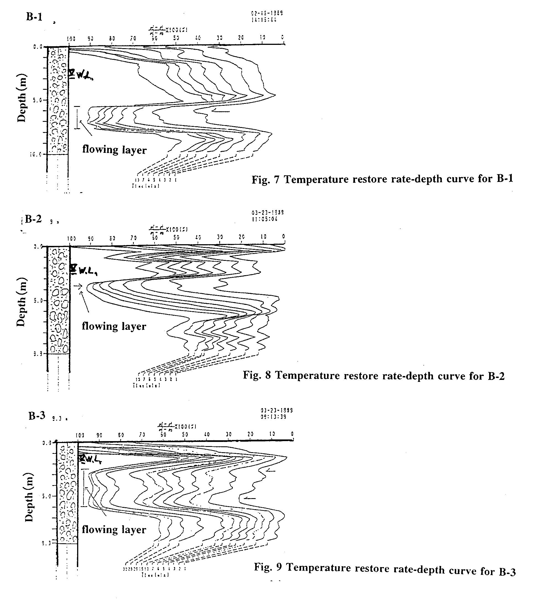
3-3 Multiple-points temperature logging
To confirm the above results, some boreholes were dug at the location shown in Fig. 6, and the multiple-points temperature logging were carried out. Measurement results were shown in Fig. 7-9. It could be seen very clearly that a few groundwater flowing layers exist.

4 Conclusion
The investigation results show that the survey method of ground temperature is very effective to choose a location for the water well at a sandy and gravel area, and it is believed to be also effective for the water resource exploration in dry areas. We expect the investigation method will be applied in dry areas as well.

5 References
TAKEUCHI, Atsuo (1980),"Method of Investigating Groundwater-Vein-Streams by Measuring One-meter-depth in Landslide Areas, Part 1", Journal of Japanese Association of Groundwater Hydrology, Vol.22, No.2, pp.11-39.
TAKEUCHI, Atsuo and Toshio UEDA (1989),"Detecting method of groundwater flowing layer by multi points temperature logging", The 34th symposium on soil mechanics and foundation engineering, pp.325-332 (in Japanese).
YUHARA, Kozo (1955),"Geothermal Prospection of Underground Heat Source", Society of Exploration Geophysicists of Japan, Vol.8, No,1,pp.27-33.

