The effect of storage location on collected rainwater quality

Kunihiko Kitamura, Ichiro Kita, Atsuo Takeuchi
Department of Agricultural Engineering
Ishikawa Agricultural College
1-308 Suematsu, Nonoichi, Ishikawa, 921-8836 Japan
E-mail: kk@ishikawa-c.ac.jp

Abstract

Water quality in stored rainwater changes during storage for various reasons and it is necessary to investigate these variations in order to use it safely. In this paper, an attempt is made to examine the effect of the location of storage reservoirs on rainwater quality. The experiment was, however, carried out using groundwater instead of rainwater due to a lack of rainfall during the period of the experiment. Water that was stored in the containers located both indoors and outdoors was analyzed for ammonia nitrogen, nitrite nitrogen, nitrate nitrogen, turbidity, color, coliform bacteria and bacteria periodically for about three months from the beginning of August to the end of October. The results obtained show that variations in water quality were little different between the water stored indoors and outdoors, but the appearance of water was quite different.

Introduction

Rainwater is a valuable water resource. In Japan, however, although direct utilization of rainwater such as rainwater storage in the home and the office has been gradually popularized, it is not yet widespread in Japan (SHASEJ 1997). It is expected that its installation will bring a huge benefit, for example, a reducing urban water demand and the provision of drinking water in emergencies such as earthquake disaster, etc.

Generally speaking, rainwater quality is acceptable except for the initial rainfall (Yasutake et. al. 1992). However, it was reported that stored rainwater changes in water quality during the storage due to various reasons (Nagado et al. 1992). In order to utilize the stored rainwater safely from health side, it is necessary for the stored rainwater to satisfy a certain water quality standard.

This paper aims to clarify the effect of storage location on variations in the water quality of stored rainwater. However, due to lack of rainwater for storage this year, the experiment was carried out using groundwater that was pumped up and sprinkled onto the roof of a greenhouse instead of using natural rainwater. The experiment was carried out during about three months from the beginning of August to the end of October and the quality of the water stored in the containers was measured periodically.

The results obtained from the experiment show little variation in water quality between the water stored indoors and outdoors, although the appearance of water was quite different.

Methodology

Water Collecting and Storage
In this experiment, an attempt was made to examine the effect of the location of the storage containers on variations in water quality. A condition was that no water be added to the stored water during storage. Therefore, it was necessary that the container be filled up with rainwater in the single event of rainfall. However, we did not have a sufficient amount of rainfall for the experiment, so the experiment was carried out using groundwater that was pumped up from a well and sprinkled instead of using rainwater. Groundwater was collected from a greenhouse, which had a roof with an area of 80 m³ and equipped with a gutter. The runoff was stored in polyethylene containers with the volume of 0.3 m³. Figure 1 shows the greenhouse and the gutter.

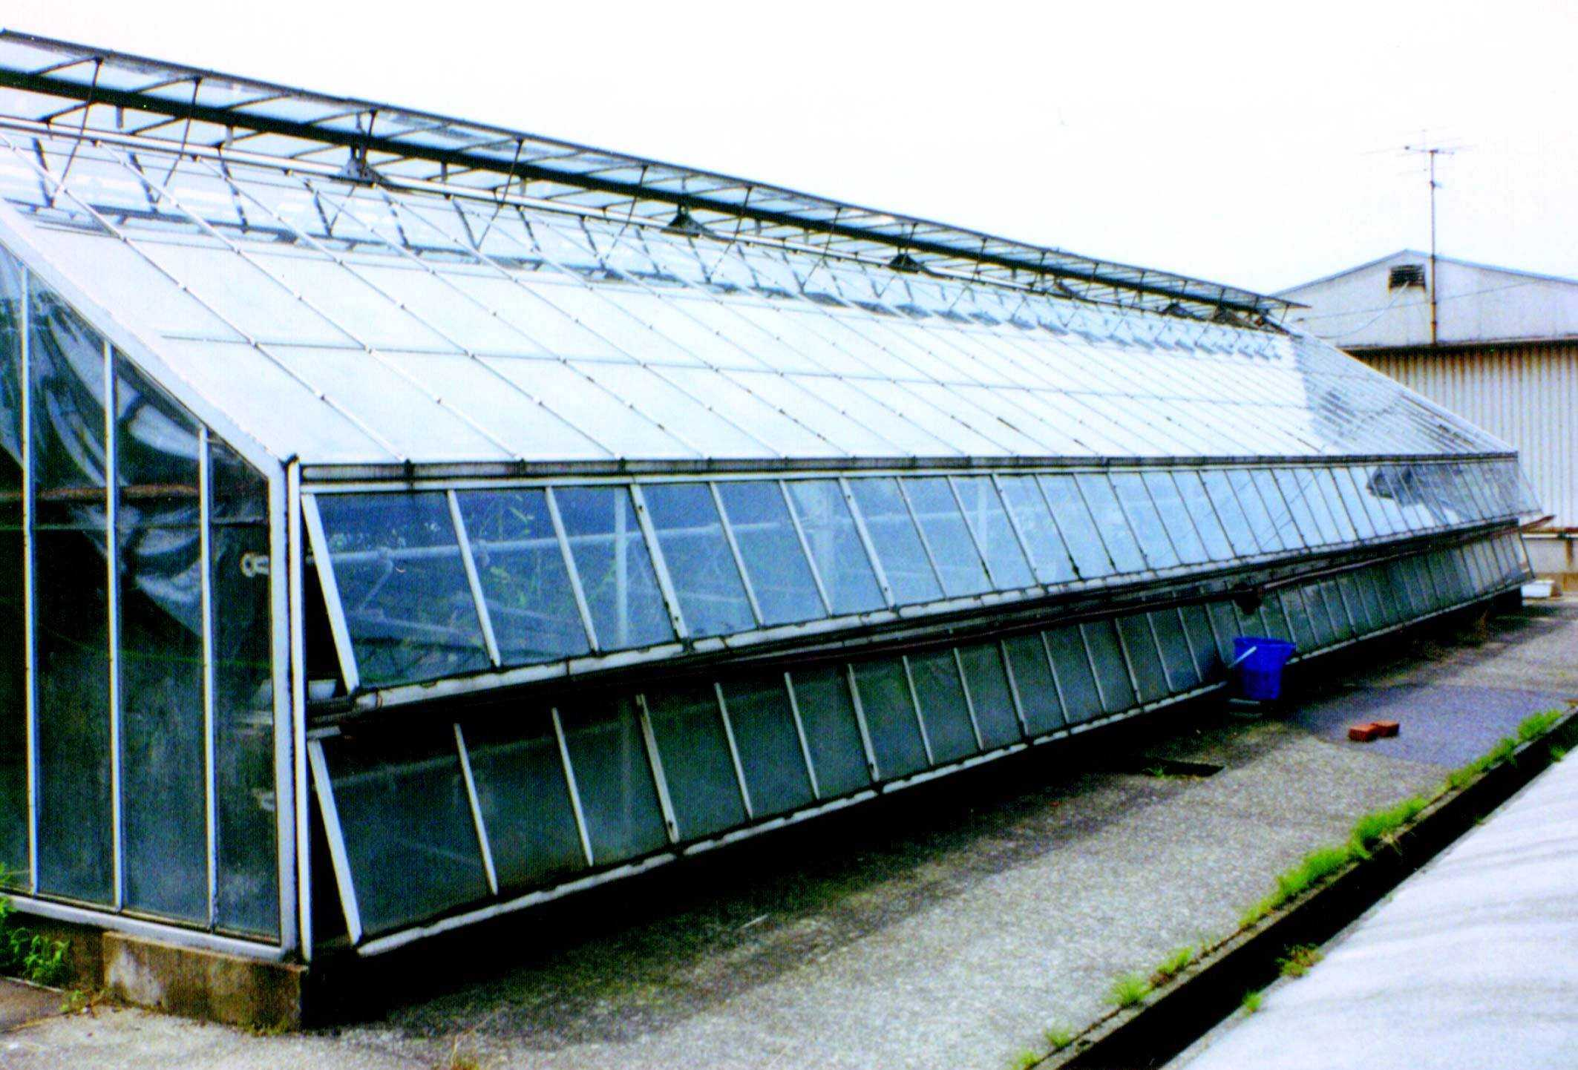

Photo 1 Greenhouse and gutter

Sprinkled water was collected in a bucket with the volume of 0.02 m³ and transferred to the containers. Its intensity was about 5 mm/h estimated as a typical rainfall intensity. The collected water was stored in two containers. One container was placed indoors out of the direct sunlight. It was rather dim without artificial lighting and it had sunlight through a dark glass window. The other was placed outdoors and exposed to the direct sunlight from sunrise until about 3pm. when the place became shaded by the building. Figures 2 and 3 show two containers, respectively.

It did not rain for about one month after the gutter was fitted. During this period airborne debris (e.g., soil particles, bird droppings and insect carcasses) accumulated in the gutter and on the greenhouse roof. Water was not stored for half an hour after the beginning of sprinkling so that the debris could be flushed away and not be contained in stored water. However, not all airborne debris was flushed away from the appearance of water collected in the bucket.

Water Quality Parameters and Methods for Analysis

Water was analyzed for ammonia nitrogen, nitrite nitrogen, nitrate nitrogen, turbidity, color, Coliform bacteria and bacteria. Ammonia nitrogen, nitrite nitrogen and nitrate nitrogen were measured in mg/L using the HACH model DR/700 colorimeter and HACH method (Salicylate method, Diazotization method and Cadimium reduction method, respectively). The limits of detection of ammonia nitrogen, nitrite nitrogen and nitrate nitrogen were 0.024 mg/L, 0.0038 mg/L and 0.024 mg/L, respectively. Turbidity and color were measured in JIS unit(°) using KYORITSU model WA-PT-4 turbidity/color comparator set, where JIS is the Japanese Industrial Standard. Turbidity was measured in increments of 0.5°, 1°, 2° and 3°. Color was measured in increments of 1°, 2° and 3°. Coliform bacteria and bacteria were tested using test paper that could indicate only their presence.

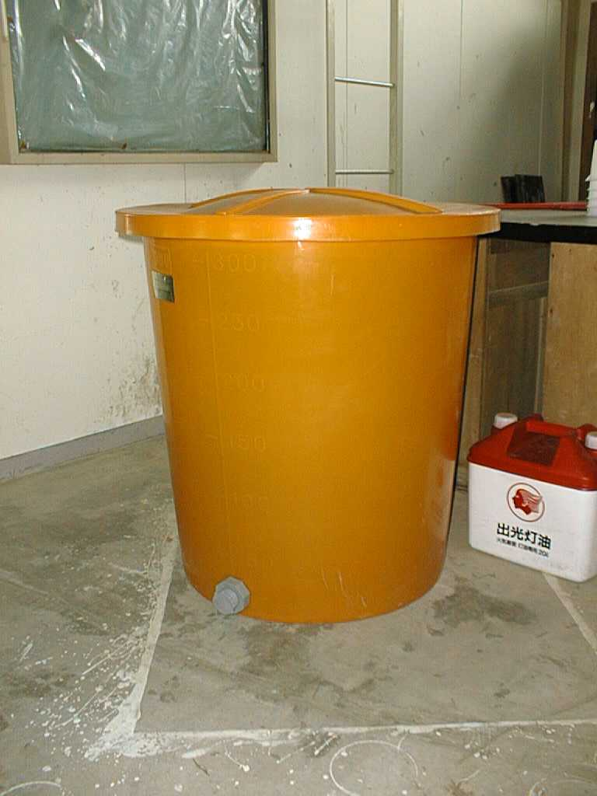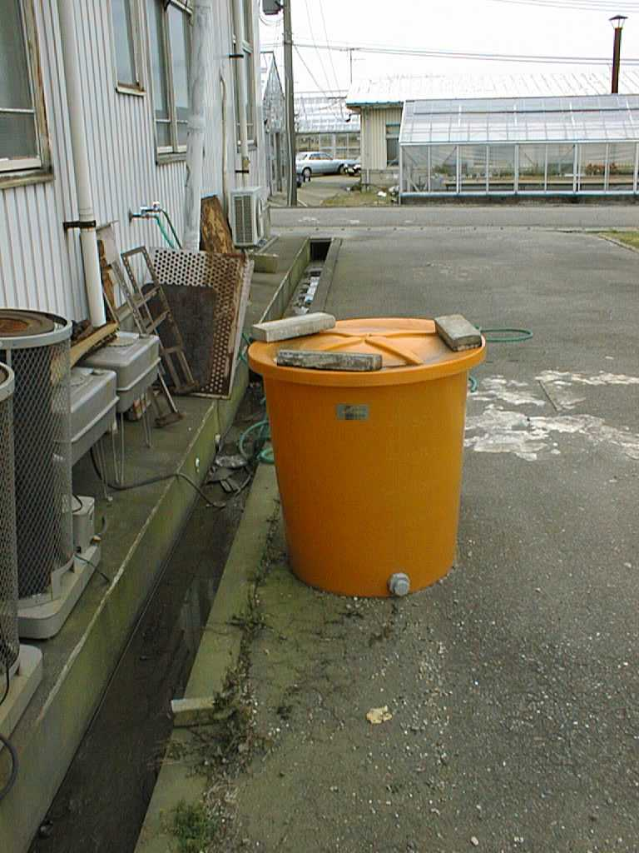

Photo 2 Container indoors Photo 3 Container outdoors

All water quality parameters were measured from August 2 to August 8 daily and from August 15 to October 30 weekly. All sets of water quality were carried out at about 1 P.M. Water pumped from the well was analyzed for the same parameters to compare with water for storage before the experiment. Rainwater, enough for a water test, was collected and analyzed.

Results and discussion

The results obtained from these measurements are shown in Table 1. Water without sprinkling did not contain airborne debris. Ammonia nitrogen in it was below the limit of detection. It was also below the limit of detection on the first day of storing. Ammonia nitrogen indoors increased from 0.03 mg/L to 0.10 mg/L. Ammonia nitrogen outdoors increased to 0.08 mg/L on day 1 and decreased to 0.04 mg/L next day. After that, it increased to 0.07 mg/L on day 6. The presumed source of ammonia nitrogen was from bacteria associated with bird droppings and insect carcasses collected together with the water.

Nitrite nitrogen in water stored indoors was all below the limit for detection both initially and during storage. Nitrite nitrogen stored outdoors was below the limit of detection to day 6. It increased from 0.042 mg/L on day 13 to 0.55 mg/L on day 27 and after that decreased to below the limit of detection on day 83.

Nitrate nitrogen in water indoors varied between 1.8 mg/L and 2.7 mg/L repeating an increase and a decrease until day 20. After that, it decreased. Nitrate nitrogen levels in the outdoor storage was almost constant during the first week and then, decreased. Table 1 Results of Measurements of Water Quality
Color in both indoor and outdoor storage containers were all below 2° during storage. Turbidity in both indoors and outdoors was all below 0.5 ° except the first day of storing.

Coliform bacteria and bacteria were detected in all cases. The cause was due to the bird droppings in the gutter and on the roof of the greenhouse that was not flushed away and was collected together with water, since these were not initially detected in the pumped water.

Stored water after storage was shown in Figs. 4 and 5. There was quite a difference between them. Particles accumulated on the bottom of both containers. A membrane on the water surface and the particles attached inside were only detected in the container kept outdoors. The water itself was very clear in both containers.

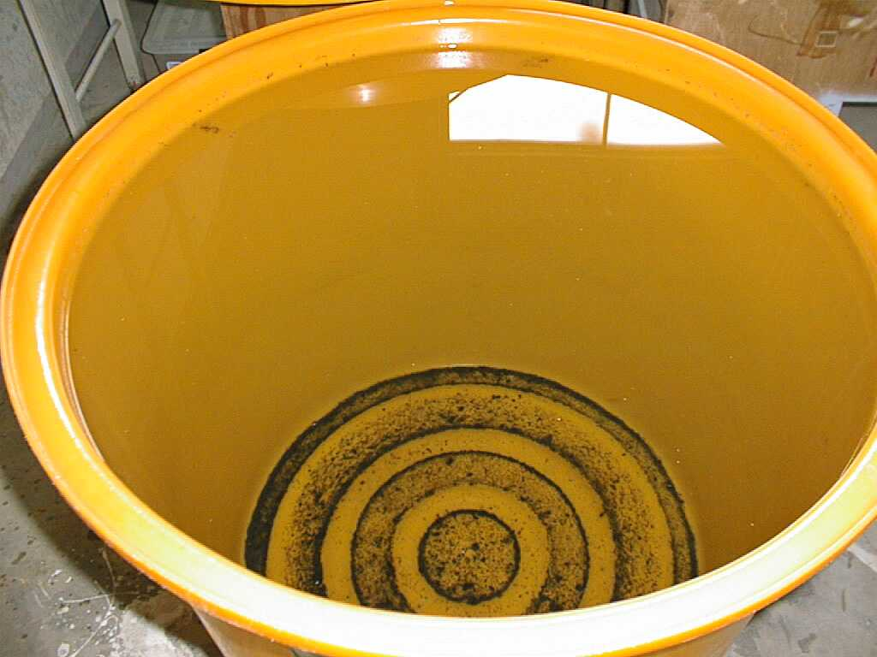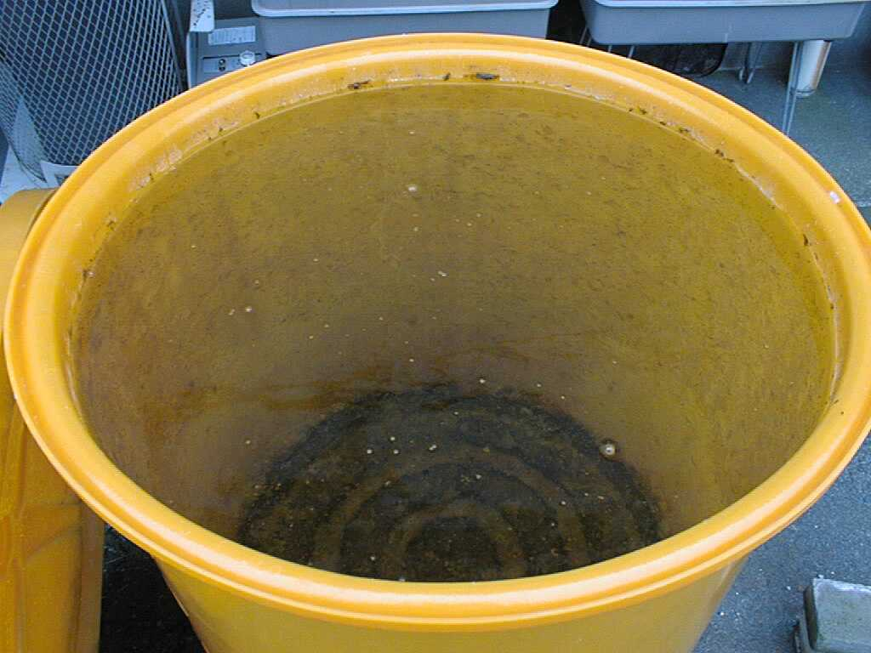

Photo 4 Appearance of water stored Photo 5 Appearance of water stored
indoors outdoors

The measurement results obtained from the experiment show that there was little difference in the water quality whether stored indoors or outdoors. Therefore water quality was little affected but the appearance was affected by the location of the storage container.

Japanese water quality standard for each constitution is as follows:
1. Nitrite nitrogen and nitrate nitrogen are less than 10 mg/L in total.
2. Turbidity was less than 5°.
3. Color is less than 2°.
4. The number of colonies formed from sample water of 1 ml by bacteria is less than 100.
5. Coliform bacteria are never detected.

The experiment was carried out using water that was pumped up from the well instead of rainwater. The measurement results of water test for rainwater were obtained. The results are as follows:
1. Rainwater ammonia nitrogen was 0.42 mg/L.
2. Rainwater nitrate nitrogen was below the limit of detection.
3. The other was no difference between them.

From the above results, the stored water could satisfy the standard for nitrite nitrogen, nitrate nitrogen, turbidity, and color in both indoors and outdoors. Since ammonia nitrogen is indicator of faecal contamination, there seems to be a problem in utilization of stored water for drinking. Coliform bacteria were also detected during storage and the stored water could not satisfy the standard.

Conclusion

The results obtained from the experiment are as follows:

1. There was little difference in the variations of water quality between water stored indoors or outdoors. The water quality was hardly affected by the location of the storage container.

2. There was quite a difference between water stored indoors and outdoors. The appearance was affected by the location of the storage container.

References

IDE, M., HIGUCHI, A., OHARA K., and TAKEYAMA K., Study on Separate Collection and Utilization on Rainwater, Proceedings, 1995 Workshop of Japan International Rainwater Catchment System Association, Matsuyama, Japan, pp. 105-111, 1995 (In Japanese)

KITAMURA, K., KITA, I. and MINAMI I., The Effect of Storage on Rainwater Quality, Proceedings, 8th International Conference on Rainwater Catchment Systems, Tehran, I. R. Iran, Vol.1, pp.590-595, 1997

NAGADO, K. and MORITA, D., Study on Water Quality in Rainwater Utilization in Okinawa, Proceedings, 1994 Workshop of Japan International Rainwater Catchment System Association, Naha, Japan, pp. 27-36, 1994 (In Japanese)

SHASEJ, The Society of Heating, Air-conditioning and Sanitary Engineers of Japan, Rainwater Utilization System Design and Practice, Tokyo, Maruzen, 1997 (In Japanese)

YASUTAKE, S., TANAKA, T, MAKITA, N. and HIROSE S., Research on Rainwater Purification, Proceeding, Regional Conference 1992 International Rainwater Catchment Systems Association, Kyoto, Japan, Vol. 2., pp. 560-568, 1992

Storage  duration | NH₄⁻-N  (mg/L) |  | NO₂⁻-N  (mg/L) |  | NO₃⁻-N  (mg/L) |  | Color  (°) |  | Turbidity  (°) |  | Bacteria |  | Coliform
before | >0.024 |  | >0.038 |  | 1.1 |  | 2 |  | >0.5 |  | n |  | n
 | in | out | in | out | in | out | in | out | in | out | in | out | in | out
0 | >0.024 | >0.024 | >0.038 | >0.038 | 2.4 | 2.3 | 2 | 2 | 1 | 1 | p | p | p | p
1 | 0.03 | 0.08 | >0.038 | >0.038 | 1.7 | 1.8 | 2 | 2 | >0.5 | >0.5 | p | p | p | p
2 | 0.03 | 0.04 | >0.038 | >0.038 | 2.3 | 2.2 | 2 | 2 | >0.5 | >0.5 | p | p | p | p
3 | 0.04 | 0.06 | >0.038 | >0.038 | 2.1 | 2.2 | 2 | 2 | >0.5 | >0.5 | p | p | p | p
4 | 0.05 | 0.06 | >0.038 | >0.038 | 2.1 | 2.2 | 2 | 2 | >0.5 | >0.5 | p | p | p | p
5 | 0.05 | 0.07 | >0.038 | >0.038 | 1.9 | 2.2 | 2 | 2 | >0.5 | >0.5 | p | p | p | p
6 | 0.07 | 0.07 | >0.038 | >0.038 | 2.0 | 2.2 | 2 | 2 | >0.5 | >0.5 | p | p | p | p
13 | 0.10 | >0.024 | >0.038 | 0.042 | 2.1 | 2.0 | 2 | 2 | >0.5 | >0.5 | p | p | p | p
20 | >0.024 | >0.024 | >0.038 | 0.050 | 2.7 | 1.9 | 2 | 2 | >0.5 | >0.5 | p | p | p | p
27 | >0.024 | >0.024 | >0.038 | 0.055 | 2.5 | 1.8 | 2 | 2 | >0.5 | >0.5 | p | p | p | p
34 | 0.03 | >0.024 | >0.038 | 0.054 | 2.3 | 1.3 | 2 | 2 | >0.5 | >0.5 | p | p | p | p
41 | >0.024 | >0.024 | >0.038 | 0.050 | 2.3 | 1.3 | 2 | 2 | >0.5 | >0.5 | p | p | p | p
48 | >0.024 | >0.024 | >0.038 | 0.046 | 1.8 | 1.2 | 2 | 2 | >0.5 | >0.5 | p | p | p | p
55 | >0.024 | >0.024 | >0.038 | 0.042 | 1.6 | 1.1 | 2 | 2 | >0.5 | >0.5 | p | p | p | p
62 | >0.024 | >0.024 | >0.038 | 0.049 | 1.6 | 0.9 | 2 | 2 | >0.5 | >0.5 | p | p | p | p
69 | >0.024 | >0.024 | >0.038 | 0.042 | 1.8 | 0.7 | 2 | 2 | >0.5 | >0.5 | p | p | p | p
76 | >0.024 | >0.024 | >0.038 | 0.039 | 1.8 | >0.66 | 2 | 2 | >0.5 | >0.5 | p | p | p | p
83 | >0.024 | >0.024 | >0.038 | >0.038 | 1.9 | >0.66 | 2 | 2 | >0.5 | >0.5 | p | p | p | p
90 | >0.024 | >0.024 | >0.038 | >0.038 | 1.8 | >0.66 | 2 | 2 | >0.5 | >0.5 | p | p | p | p
97 | >0.024 | >0.024 | >0.038 | >0.038 | 1.8 | 0.7 | 2 | 2 | >0.5 | >0.5 | p | p | p | p
in: Storage container located indoors, out: Storage container outdoors,
p: Positive, n: Negative

