Nitrogen Transport Through the Vadose Zone of the Bisheh Zard Aquifer

M. Mohammadnia, S. A. Kowsar
Fars Research Center For Natural Resources
and Animal Husbandry
P.O.Box 71365-458, Shiraz, Iran
E-mail: nafssis@sums.ac.ir

Abstract

The critical water shortage, an abundance of floodwaters and the very large empty spaces available in the potential aquifers have made the artificial recharge of groundwater (ARG) the method of choice for storage and transport of the required water in the Iranian deserts. The Bisheh Zard Aquifer, with the capacity of more than 100x106[-1] m3, provides an ideal underground reservoir that could supply water to 4 villages for 5 years if fully recharged. However, the presence of geologic-N in the watershed is a cause for concern. Although the inhabitants of the Gareh Bygone Plain (GBP), who consume the water that drains from the watershed do not report any ill effects, the reported cases of digestive tract cancer and the blue baby syndrome in the USA make us apprehensive for the water users' safety. As palygorskite translocation to a depth of 7.5 m has been ascertained in a previous study and the reported anion exchange capacity of this clay species is considerable, therefore, the N pollution of the aquifer and groundwater in the ARG systems of the GBP is a possibility. The relationships between the clay translocation and the contamination of the aquifer will be discussed.

Introduction

Water shortage is affecting a large segment of the human population, mostly in the arid and semi-arid zones. Unfortunately, pollution makes some of their very meager water supplies unfit for human consumption. As the artificial recharge of groundwater (ARG) is a proven method of supplying water to the areas with potential aquifers, the pollution potential of groundwater by the application of this technique should be studied in detail. As floodwater is the only available source for the ARG in many deserts, and is turbid by nature, therefore, its turbidity is a cause for concern due to the following shortcomings:
1. Settlement of the suspended load onto the ARG systems results in their gradual impermeability, thus the shortening of their useful life (Johns and Grim, 1954; Behnke, 1969; Brown and Keys, 1985); and
2. Transportation of the potential pollutants, mostly the organochemicals, through the vadose zone deteriorates the water quality, thus affecting the health of the consumers (Wood and Bassett, 1975; Foster et al., 1986; Owens and Edwards, 1992; Ma and Spalding, 1997).

Of special interest in this respect is the leaching of nitrates and translocation of herbicides and pesticides, absorbed on the surface of organic matter and fine clay particles, from the surface of agricultural fields to the water-table. Industrial wastes and sewage are other hazardous pollutants of the groundwater.

The presence of geologic-N in the outcrops of the Mio-Pliocene Agha Jari Formation (AJF) in the Zagros Mountain Ranges in the west and southwest of Iran (Yazdian, 1996) challenges the practitioners of the ARG method to protect the people who depend on groundwater from the potential hazards of consuming waters which contain more than 10 ppm of nitrate-N (45.7 ppm NO -3, Spalding and Exner, 1993). As the floodwater, which emanates from the AJF in the Gareh Bygone Plain (GBP), is utilised to recharge the aquifers, and this water contains up to 77 ppm NO -3 and 38 ppm NH+4, and since some ammonium might be converted into NO -3 as the water flows through the vadose zone, thus increasing the nitrate concentration and enhancing the pollution hazard, the study of N translocation from the surface of the ARG systems to the regional water-table assumes a very special significance. This is a follow up of a study on the clay translocation beneath the ARG systems (Mohammadnia and Kowsar, 1998).

Materials and Methods

Outcropping of the Miocene-Pliocene AJF in the GBP makes the Bisheh Zard Basin (BZB) an ideal runoff producing watershed, and the debris cone formed by the Bisheh Zard River, emanating from this basin, a good representative of vast, potential recharge sites in the Zagros Mountain Ranges. The alluvium is derived from the Miocene-Pliocene sandstones, siltstones and marls (AJF), and the Pleistocene calcareous and cherty cobbles and pebbles (Bakhtyari Formation) of the Gar Mountain. Sandstone rocks of up to 40 cm in length are frequently seen in the debris cone.

The GBP is 200 km to the SE of Shiraz, Iran (28 37 N, 53 55E, 1140m above mean sea level). Mean annual precipitation and the Class A pan evaporation are 243 and above 3200mm, respectively, based on the records from the Baba Arab Climatological Station, 20km to the west of the study site (Pooladian and Kowsar, 1997). More details about the site and its ARG activities may be found elsewhere (Kowsar, 1991). Alluvium samples for N determination were collected at 1m intervals from the surface to a depth of 20m in the Bisheh Zard 4 ARG system, and to a depth of 23m in the control, which is outside of the waterspreading area (Fig.1). These were the same wells used for clay translocation studies (Mohammadnia and Kowsar, 1998). Ammonium and nitrate contents of the samples were determined using the micro-Kjeldahl method.
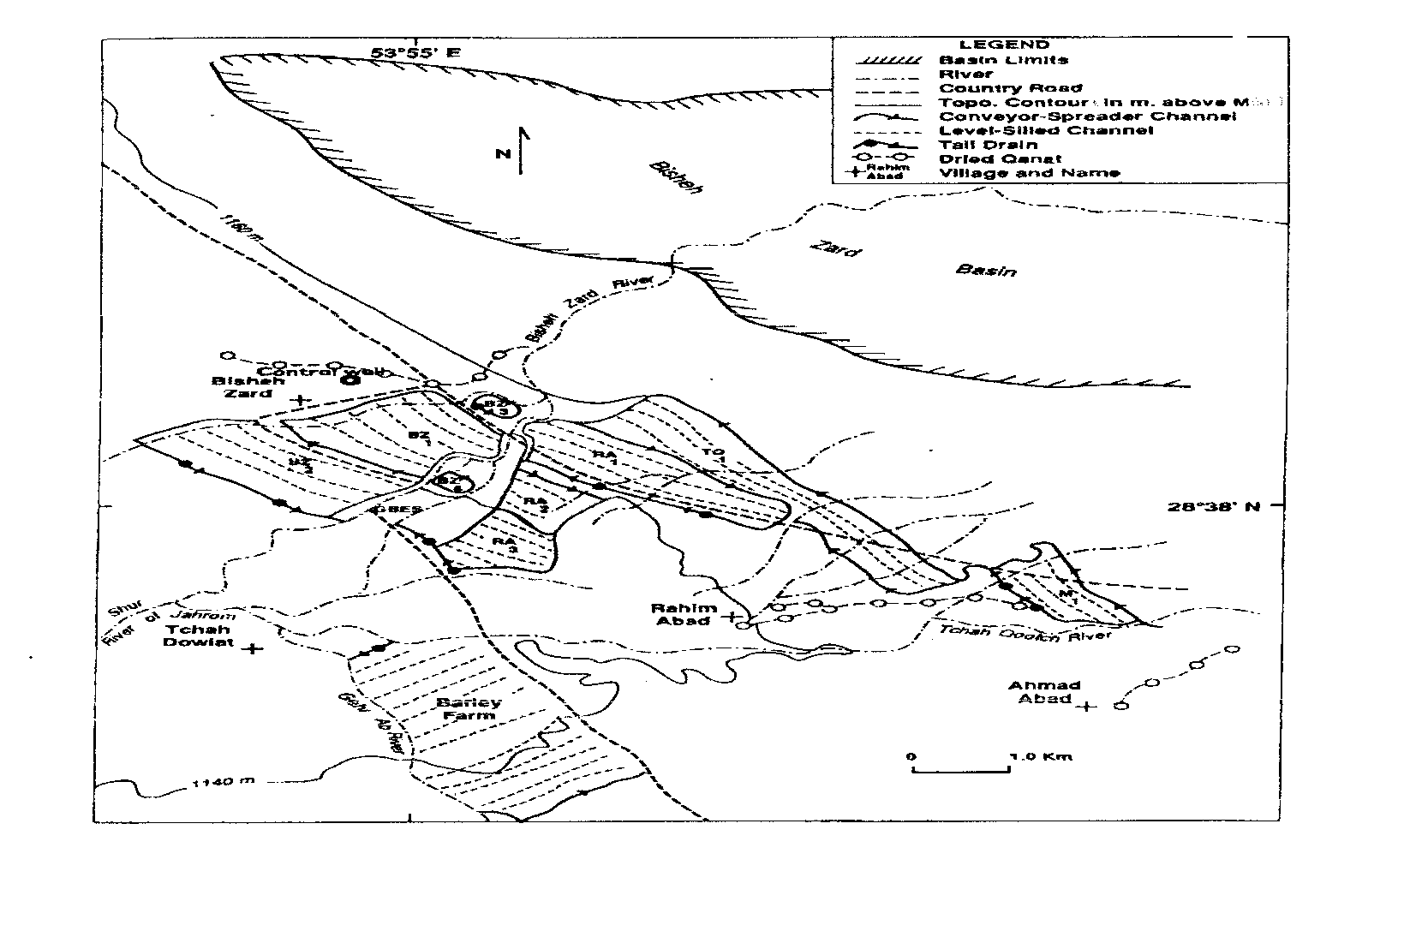
Fig.1. Sketch map of the Gareh Bygone Plain floodwater spreading systems

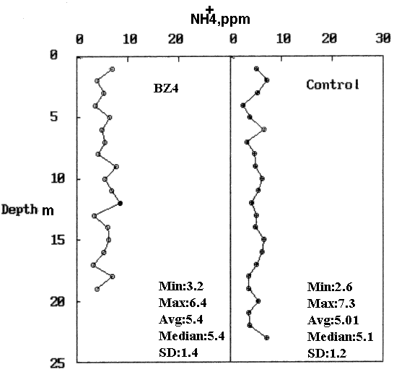
Fig.2. Ammonium concentration in the soil profile in the BZ4 sedimentation basin and outside of the ARG systems, control.

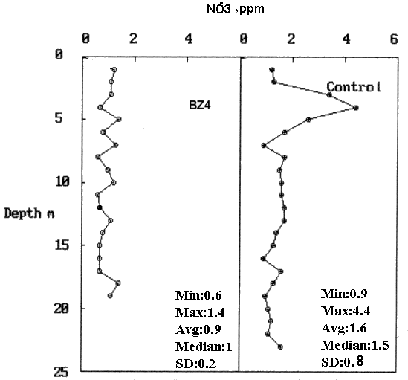

Fig.3. Nitrate concentration in the soil profile in the BZ4 sedimentation basin and outside of the ARG systems, control.

Results and Discussion

The NH+4 and NO-3 contents of the samples are presented graphically in Figs. 2 and 3. While the NO-3 content in the ARG system was lower than that of the control in 17 out of 20 samples, the NH+4 concentration was another matter; it was higher in 10 samples and lower in another 10 samples. The lower NO-3 content of the ARG system is contrary to our expectation, as the profile had been recharged for 13 years with floodwater containing geologic-N, and the N released from the deteriorating eucalyptus leaves which litter the sedimentation basin (SB) floor and are covered by the suspended load any time the system receives floodwater.

For lack of solid evidence we can only speculate on this matter. As the eucalyptus is a prodigious water consumer it absorbs the dissolved NO-3 along with water, thus its concentration in the profile is maintained at a very low level. Another highly speculative reason which requires further detailed research is the probable high anion exchange capacity of palygorskite which is rather abundant in the SB from the surface to a depth of 7.5m, and possibly down to the water-table. Since the P retaining property of this clay species has been proven (personal communications, Dr.Khademi, the Isfahan U. of Tech., reporting on the work of Dr.Shariatmadari), NO-3 is filtered out of the percolating floodwater for later absorption by the eucalyptus roots, thus decreasing its leaching to the lower depths.

An anomaly in NO-3 concentration in the 3-5m depth of the control well worth noticing. As this area is very close to the Bisheh Zard Village it could have been a corral for livestock and the natural leaching through the ages has caused the highest NO-3 concentration at a depth of 4 m. This could be used as an evidence that the deepest penetration of the rainwater in this area has been 4-5 m.

Conclusions

Despite our apprehension regarding the pollution potential of geologic-N in an artificial recharge of groundwater scheme, systematic sampling from the soil surface to the water-table, and NH+4 and NO-3 determination in the samples have shown that our concern may have been baseless. Apparently, eucalyptus trees, which extend their roots to the water-table, and perhaps palygorskite, with its high anion exchange capacity, and probably other unknown agents, filter out the NO-3 impurity of the recharge water and make it harmless. Further research, particularly with co-operation of cancer specialists, will shed light on the subject.

Acknowledgements

Miss F.Nabati and Mr. S.Eskandarnia are thanked for typing this manuscript.

References

Behnke, J. J. Clogging in surface spreading operation for artificial groundwater recharge. Journal of Water Resources Research 5 : 870 - 876 (1969).
Brown, R. F., and W. S. Keys. Effects of an artificial recharge on an alluvial aquifer, Ogallala Formation, Texas. USGS Water - Supply paper 2251, 56p. (1985).
Foster, S. S. D. Getting to grips with groundwater pollution protection in developing countries. Natural Resources Forum 10: 51-60 (1986).
Johns, W. D., and R. E. Grim. Quantitative estimation of clay minerals by diffraction methods. Journal of Sedimentation Petrology 24: 242-251 (1954).
Kowsar, A. Floodwater spreading for desertification control: An integrated approach. Desertification Control Bulletin (UNEP) 19: 3-18 (1991).
Ma, L., and R. F. Spalding. Effects of artificial recharge on groundwater quality and aquifer storage recovery. Journal of the American Water Resources Association 33: 561-572 (1997).
Mohammadnia, M., and S. A. Kowsar. Clay translocation beneath the artificial recharge of groundwater systems. In International Research and Training Center on Erosion and Sedimentation Proceedings, 7 - 10 Sept. 1998, Beijing, China. p. 558-564 (1998).
Owen, L. B., and W. M. Edwards. Long - term groundwater quality changes from a one - time surface bromide application. Journal of Environmental Quality 21: 406-410 (1992).
Pooladian, A., and S. A. Kowsar. Salinity reduction in groundwater by floodwater spreading. In B. Aminipouri and J. Ghoddusi(eds.) Proceedings, 8th International Conference on Rainwater Catchment Systems, 25 - 29 April 1997, Tehran, I. R. Iran. 1:128-135 (1997).
Spalding, R. F., and M. E. Exner. Occurrence of nitrate in groundwater - A review. Journal of Environmental Quality 22: 392 - 404 (1993).
Wood, W. W., and R. L. Bassett. Water quality changes related to the development of anaerobic conditions during artificial recharge. Journal of Water Resources Research 11: 553 - 558 (1975).
Yazdian, A. R. Geologic nitrogen in the Gareh Bygone Plain, Fasa: Characterisation and quantitative determination. MS Thesis, Tarbiat Modarres Univ., Tehran, Iran (1996).5

