Comparative Review of Drinking Water Quality from Different Rain Water Harvesting Systems in Sri Lanka

Tanuja Ariyananda, Co-ordinator, Lanka Rain Water Harvesting Forum, No.5, Lionel Edirisinghe Mawatha, Kirulapone, Colombo 5, Sri Lanka
Email:tanujaa@itdg.lanka.net

Abstract
The main constraints on using rainwater for domestic use have been the water quality aspects. The quality of rainwater collected depends on the cleanliness of the atmosphere, materials used for the catchment surface, gutters and down pipe of the storage tank and the water extraction device. In the hill country and in the north central province acid rain has been recorded and in the western province rainwater has carried high nitrate levels. Compared to other industrialised countries in the region, however, acid rain is still not considered a serious problem in Sri Lanka.

This study reviews the quality of rain collected throughout Sri Lanka from different types of storage tanks and roofs. It will compare the traditional rainwater collecting methods with the present available technology of the Community Water Supply and Sanitation Project (CWSSP). It looks as the health aspects of drinking rainwater related to biological contamination and indirectly due to disease vectors like mosquito and other insects/pest breeding in the stored water. Recommendations will be given on the different water treatment methods along with some suggestions for improvement.

The result shows that the rainwater collected and stored with adequate care meets the microbiological standards set by the WHO for total coliform in drinking. The data obtained reveal that the quality of the rainwater collected depends on the storage and the management of the system.

Introduction

In Sri Lanka rain water harvesting for domestic use was practised for many centuries, such as for example the 5th Century Sigiriya fortress complex, the sophisticated rain water-cum-reservoir systems. In recent years many of these rain water collection skills have become obsolete due to introduction of pipe supplies, boreholes or protected wells or springs. However the pressures of increasing population and competition for resources in the second half of the 20th century have forced people to settle in areas that have less water resources. In certain part of the dry zone, the coastal belt, with salt water intrusion into the ground water, and some uphill localities in the wet zone, rainwater harvesting remains an important, and sometimes the sole, source of water.

More than 75% of the island's landmass receive minimum of 1250 mm annual average rainfall and rain water harvesting is feasible in all zones. Rainfall pattern in Sri Lanka exhibit a noteworthy regional and seasonal variation (Abeyratna, 1998). Rainfall pattern is influenced by two major monsoons. The North East Monsoon bringing rain to the dry zone of the country from November through April while the South-West monsoon brings rain to the wet zone from May through October.

The main constraints on using rainwater for domestic use have been the water quality aspects. Quality of rainwater collected depends on the cleanliness of the atmosphere, material used for the catchment surface, gutters and down pipe, the storage tank and the water extraction device.

Atmosphere

Precipitation comes from the condensed vapour of meteoric water and its water quality relies to a greater extent on local environment conditions. The composition of the precipitation is highly influenced by the combustion of fossil fuels, large-scale industrial emissions and dust and debris derived from both natural and human influences. Acid precipitation occurs when SO₂ and NO, emitted by burning of coal, natural gas and petroleum products, oxidised in the atmosphere form sulphuric acid and nitric acid

Ileperuma (1988) reports of acid rain (rain water having pH <5.6 from the hill country and the north central province. This was attributed to winds carrying exhaust fumes from western province (Colombo), fumes originating from power stations in Tamil Nadu and increased use of diesel fuel from rice mills which had run on rice hull before. However, acid rain is not thought to be a major problem in Sri Lanka compared to more industrial countries in the region such as Singapore, Thailand, Indonesia and Malaysia (Ileperuma, 1998).

Storage of Rain water

Storage of rainwater is one of the major factors influencing the quality of water. This study compares the water quality data collected from the traditional square brick tanks as well as CWSSP tanks.

Traditional Methods
Traditional domestic rainwater harvesting in Sri Lanka can be categorised in three methods: open air collection, collection from tree trunks and collecting from temporary gutters into square brick tank (Ariyabandu, 1998). Many of the traditional systems collect water during the wet-day or wet-season only and do not store water for more than few days. A study reveals (Hapugoda 1995) that rain water harvesting for domestic consumption was extensively practised especially in upland areas (Kundasale, Bandarwela). In these areas rainwater is collected from permanent roofs made of tiles, asbestos or tine sheet. Thatched roofs have also been used for rainwater collection in some remote villages; however, this water is not used for drinking. Some of the gutters used in traditional system are tin sheets, banana stems, Aricunut (Areca catechu) sheaths and Bamboo (Ariyabandu 1998).

Common storage tanks found in Kandy district (Ahaspokuna) and in some localities in the dry zone are rectangular square cement tanks with a capacity of 1500-3000 litters. These tanks are generally kept open, (sometimes covered with a mesh) and water supplies are sufficient for an average family for a few days. The average cost building such tank is Rs. 3,000-6,000

CWSSP Tanks
In the last few years there has been a revival of rainwater harvesting and research was conducted to improve the technology. In 1992, the government of Sri Lanka initiated the Community Water Supply and Sanitation Project (CWSSP) with assistance from the World Bank. The objective is to provide affordable safe drinking water and sanitation facilities to rural community in Badulla, Matara and Ratnapura district. During the implementation of CWSSP, it was noted that several villages in Badulla district could not be served with available conventional water supply technology. For these uphill settlements, rainwater harvesting would be a possible option to provide water with minimum cost.

In 1995, two types of 5m³ storage tanks were designed for local use. One, called brick dome tank, (fig. 1) is constructed below ground and made of burnt brick and cement sand mortar. It is modelled after the Chinese biogas digester. The other, called ferrocement tank (fig 2.), is constructed above ground and made of chicken mesh reinforced cement sand mortar and built in the shape of sapherical jar. Both tanks collect roof runoff through a system of gutters and down pipes.

Figure 1: Underground Brick Dome tank

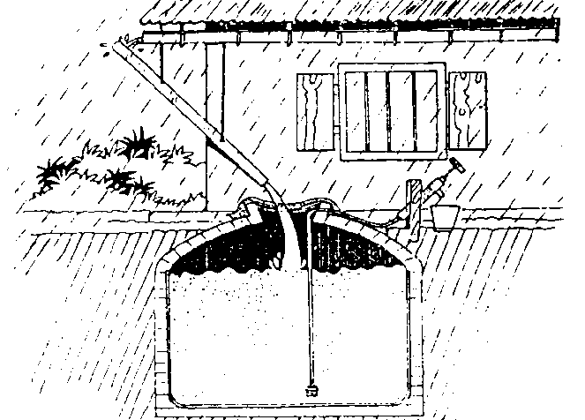

Figure 2: Above Ground Ferrocement Tank

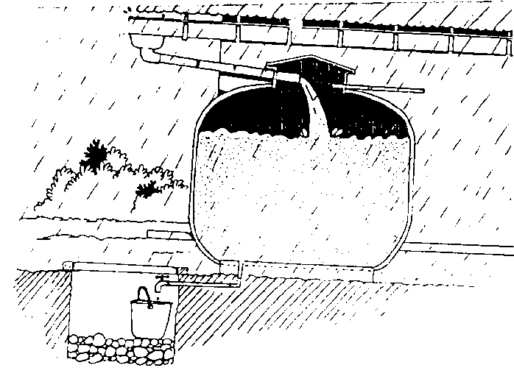

The tank was designed taking into account the roof size, rain fall data, number of people and their daily requirements as well as the subsidy offered per household by CWSSP. On this basis a family of 5 with a minimal daily requirement of 20l for a period of 50 days the storage requirement will be 5000l (5 x 20l x 50 =5000 l (5m³ )). Even with a small roof, it takes only few days to fill during the rainy season.

Table. 1 Cost estimates for Brick and Ferrocement Tanks
Description | Unit | Rate | Brick tank |  | Ferrocement Tank
 |  |  | Quantity | Total in Rs. | Quantity | Total in Rs.
Cement | Bags | 310 | 8.5 | 2635 | 8.0 | 2480
Sand | Cubes | 1700 | 0.4 | 680 | 0.6 | 1020
¾ “ Metal | Cubes | 4000 | 0.1 | 400 | 0.06 | 240
Brick | Nos. | 2/10 | 800 | 1680
Padlo Cement | Kg. | 100 | 0.5 | 50 | 0.5 | 50
Chicken wire | Sq.m. | 40 |  |  | 40 | 2200
Binding Wire | Kg. | 85 |  |  | 1 | 85
Skilled labour | Days | 250 | 4 | 1000 | 8 | 2000
 |  |  | Total Rs. | 6445 | Total Rs. | 8075
Unskilled labour | Days | 150 | 12 | 1800 | 14 | 2100
 |  |  | Total Rs. | 8245 | Total Rs. | 10175
Heijnen & Mansur (1998)

Initially only the storage tank was provided by CWSSP and beneficiaries had to include the lid of the tank, gutters, pipes, first flush device and a simple gravel filter in their system. People who included such devices in their system found improvement in the water quality. Subsequently, filters and lid of the tank were also provided by CWSSP and they were made compulsory for all types of tanks to prevent contamination. The tight cover ensures dark storage condition preventing growth of algae and breeding of mosquito larvae. A simple hand pump was also designed to extract water from the underground tank, which was later included in the subsidy.

Water Quality

Table 2 Water quality data from the two types of Rainwater harvesting tank systems

Location/types of tank | No. of samples | pH | Colour | Turbidity | Conductivity | Total Colioform per 100ml | E. Coli per 100 ml
Open rectangular tanks (Ahspokuna) | 18 | 6.0-7.5 | 5-110 | 5-15 | 50-200 | 04-1000 | 00-180
CWSSP tanks (Badulla) | 39 | 6.5-10 | 10-40, 100 | 0-16 | 45-229 | 0-170 | 0
Drinking water WHO standard |  | 6.5-8.5 | 0-30 | 0-20 | 5-1500 | 10 | 00
 Padmasiri (1998)  Mansur (1999)

pH
pH is within the required range for drinking water in the Ahapokuna open tanks, however in the CWSSP tanks 90% of the samples meet the WHO standard. High pH value were obtained from the newly build tanks due to the cement byproducts. (Table 2).

Color
High value in the Ahaspokuna tank was due to the presence of decaying leaves in these tanks. In the CWSSP tanks high value was obtained from an almost empty tank. However, 82% of the tanks meet the required WHO standards, even though none of the tanks were fitted with filters.

Turbidity
Suspended matter such as silt, dust, debris from the roof and the atmosphere are the main substance causing turbidity to increase in rainwater. Both tank types meet the required WHO standard.

Conductivity
Conductivity indicates the total dissolved solids. Water with high conductivity means high total dissolved solid content, changing taste, hardness, and other associated properties that effect portability. In both tanks the conductivity value is similar and meets the required standards.

Total Coliform at 35ºC and Fecal coliform (E.Coli) at 37ºC
Contamination by sewage or by human or animal excrement is the greatest danger associated with water for drinking. Sewage from human or animal sources may contain the causative organism of many communicable diseases. E. coli and Coliform are present in large number in faeces and sewage and can be detected in numbers as 1 in 100 ml of water. A sensitive indicator has been used to detect contamination of water by human excrements.

According to the total Coliform values (table 2) both tanks do not comply with the drinking water standards. However, E.coli has not been detected in the CWSSP tanks. This can indicate several things, one being that the contamination has been remote and E. coli had died out. Contamination can also stem from soil washing or from growth on decaying vegetation. Coliform, other than E. Coli, can also occur in water sources.

Mosquito and other insect pests have been reported in both tanks (Padmasiri, 1998, Ariyabandu, 1998²). At Ahaspokuna mosquito breeding is prevented by rearing fish in the tanks. Mosquito breeding was detected in the CWSSP tanks without a lid and unclean gutters with accumulated water. Other insects such as lizards, frogs and ants are also reported in underground brick tanks (Ariyabandu, 1998²). Most of these tanks either have no lid or the insects have gained access through overflow pipes.

Conclusion and Recommendations

Quality of collected rainwater in the CWSSP tank is better than in the traditional open rectangular tank. The main reason for this is that the CWSSP tank is covered with a lid and the absence of sunlight prevents formation of algae and spoiling of water. It also prevents mosquitoes and other insects from breeding in the tanks.

In terms of physical parameters both tanks systems satisfy the guidelines and are suitable for drinking. However, regarding bacteriological quality, the Ahaspokuna tank does not meet the required standards and the CWSSP tank indicates faecal contamination, though it may not be from humans.

None of the tanks tested used a first flush device and did not have a filter system. A simple screen made up of cloth or mosquito net and simple gravel and sand filter (later adopted by the CWSSP system) has been found to improve the water quality, preventing dust, decaying leaves and other impurities from entering the tank.

Quality of the collected water also depends on the operation and management system. Regular cleaning of the roof, tanks and gutters, as well as using an extraction device or pipe system to withdraw water and using the first flush device contribute to the collection and storage of good quality rainwater.

Good quality drinking water can be collected from rainwater, if it is collected with utmost care. Nevertheless contamination can occur through the various surface it has to pass through. Therefore, disinfecting through boiling or chlorinating or solar water disinfection is recommended to ensure the safety of water for drinking purpose.

References

Abeyaratna, M.D. A study of the potential and present status of development. Colombo, 1998, Proceeding of the Symposium on RainWater Harvesting for Water Security. Feb. 1998, OUR Engineering technology Open University, Vol.2.

Ariyabandu. R.de S. Wisdom of Traditional Collection of Rainwater for Domestic use, Sri Lanka, 1998, Report prepared for the Duryog Nivaran Program at Intermediate Technology Development Group,

²Ariyabandu, R.de S. Study of Existing Rainwater Harvesting Technology. Report prepared for Lanka Rain Water Harvesting Forum, Sri Lanka, 1998.

Hapugoda K.D. Action Research Study on Rain Water Harvesting, 1995, Sri Lanka CWSSP Ministry of Housing Construction and Public Utilities,

Ileperuma O.A. () Acid Rain Monitoring and total Chemical Analysis of Rainwater, Colombo, 1998, Proceeding of the Symposium on RainWater Harvesting for Water Security. Feb. 1998, OUR Engineering technology Open University, Vol.1, p23-25

Heijnen, H and Mansur U. Rain water harvesting in the community water supply and sanitation project, Colombo, 1998, Proceeding of the Symposium on Rain Water Harvesting for Water Security. Feb. 1998, OUR Engineering technology Open University, Vol.2.

Mansur U, Quality of Rainwater in Storage at Badulla District. Sri Lanka, 1999, Report prepared for Lanka Rain Water Harvesting Forum,

Silva W.A, Rain water for Domestic use in a dry zone village in Puttlam District. Colombo, 1988, Proceeding of the Symposium on Rain Water Harvesting for Water Security. Feb. 1998, OUR Engineering technology Open University, Vol. 1, p12-15

