Improving Environmental Characteristics in a Wide Area Around a Flood Water Spreading System, "A case study"

Masoud Nejabat
Fars Research Center For Natural Resources and Animal Husbandry.
P.O.Box 71555-617,Shiraz,Iran
Fax: (009871)765107
E-mail:nafissis@pearl.sums.ac.ir

Abstract

Soil is a huge place for reserving rainwater from where it can be released gradually and with the lowest water loss. In an area where the soil does not exist or the soil thickens is negligible, the water capacity of the soil is quickly replenished. In arid and semi-arid zones, the rain intensity is high and rain distribution is low. Thus enormous amounts of rain are lost as flooding. Water spreading systems give enough time to spread the rainwater and to infiltrate deep into the soil. The Gareh-Baigan Plain, situated in Southern Fasa, in Iran's Fars province, is an arid zone often affected by floods. The water spreading project was designed for an area of 2500 hectares with the purpose of increasing rainwater content in the soil, artificial recharge of groundwater and improving environmental aspects. The total area affected by the project is about 7500 hectare. Using computer image processing of aerial photos and satellite imagery data of the area before and after the project shows the following:
-increased cultivated area due to utilization of more water from the aquifer
-improved rangelands and forest area due to a higher water content in the upper soil layers
-reduced wind blown lands and more desertification control due to vegetation developments
-reduced soil erosion, due to flood control, in the lower part of the area
-a pleasant and natural place was created in an arid zone.
The remote sensing method allows consideration and distinction of the mentioned improvements. Application of such systems in arid and semi arid zones not only improve the water content of the soil, but also help to reduce the bad effects of floods.

Introduction

Water shortage is one of the most critical problems in the world. Some politicians believe that water shortage might cause future world wars. In recent decades, different climatic phenomena have increased this danger. Reduction of yearly rainfall and air warming are simple examples of these climatic changes. Storing water in the uplands increases the water shortage in lowlands and causes more sever conditions. Rain is the most essential factor in securing water for human needs. In arid and semiarid regions, where the annual rainfall is negligible, its distribution is also not appropriate. Irregular intensive heavy half an-hour rains in a short period (less than 4 months of the year) are obvious characteristics of these zones. Hence, only a part of the yearly rainfall has a suitable intensity and time in these regions and the remaining causes floods. Storing floodwater with dams or in aquifers is the only possibility for utilizing it in the long run. In many places, the building of huge dams is impossible due to the need of a high initial investment and special conditions. In addition, the evaporation of the stored water in the basins of dams in arid and semi arid regions is very high and causes water loss. Floodwater spreading is a simple project and has a high effectiveness. Even very negligible amount of waters can be stored that way.

Utilization feasibility of this stored water would create a positive change in the general view of an arid region. This paper tries to survey and document the general changes in the ecosystems of arid regions.

Materials and Methods

The Garth Bygone plain, part of the Sheebkuh region, is located 50 kilometers southeast of Fasa, between 53° 50${}^{'}$and 54° 15${}^{'}$latitudes and 28° 30${}^{'}$and 28° , 45${}^{'}$altitudes. The maximum and minimum elevation of this plain is 1822 and 1100 meters above sea level, respectively. The nearest meteorological station is at Baba Arab (Tamshir) with 240 mm mean annual precipitation (1968 - 1996). Of the 600-km${}^{2}$of this region, 150 km${}^{2}$are a rather flat plain and the remaining are covered by mountains. There are four relatively large ephemeral rivers named Gehrab, Bishehzard, TchehGhooch and Bidzard. It is estimated that the yearly flood volume is about 20 million m${}^{3}$with 200 mm rainfall on the average.

Ninety-four 1:20000 scale aerial photographs of a 26-year period before the initiation of the project were provided. They were examined in the form of row-column stereoscopic pairs. After preliminary visual interpretations, the photos were converted to a digital form with a scanner and entered into the computer. The conditions of the land were illustrated through special image processing. The extent and site of the wind blown land ,very poor rangeland, poor rangeland, rain-fed farms and irrigated ones were recognized. A digital 1:20000 scale map was the result of the first phase of the survey. The last satellite imageries of land sat-5 of 1998, 17 years after the initiation of the project, were provided afterwards. They were entered into the computer in a digital form with 7 bands. After atmospherically, geometrical, and shadow corrections and suitable bands combinations (1,3,5), the data image processing was commenced. A map in the scale of 1:20000 with the new conditions of the region was the result of this second phase.

Results and Discussions

Results of the two mentioned phases showed that irrigated farms have increased considerably, especially for lands located lower than the project. These increases in farmlands are seen less in other areas of the project. Since ground water is the only secure water source, the increase in irrigated farms depends on the project. Statistical evidence also shows this increase. The number of wells has increased from 16 to 110. This evidence also shows a development in water quality. An increase in forage production is seen in the maps. Field surveys also show an 11 fold increase in forage production. Before the founding of the project, the trees in the region were thinly scattered, however, after the founding of the project, a plantation of Eucalyptus and Acacia species on the flood water system has turned into a tense jungle and changed the general look of this semiarid region. A remote sensing survey shows the effects of floodwater spreading on the ecosystem of the region. Reduction of wind blown lands, desertification control, and development of vegetation, particularly trees, led to protection of the sandy soils. Field surveys also show a considerable reduction of tornadoes. The comparison of the first phase of study to the second shows that the extent of land degradation due to effects of floodwater has decreased after the project had been established. The flood water volume in the lower part of the ephemeral rivers has much decreased due to the spreading of a considerable flood water volume on the lands in upper part of the rivers.

Studies of the satellite imageries show a very vast arid zone around this site. However, the system has created a tense jungle. This plantation has provided a suitable environment for wild life. Field surveys inform about the return of different species of wild birds and animals. This site is now a favorable place for migrant birds and animals (fig.1).

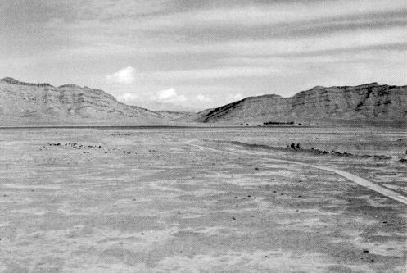

Figure 1

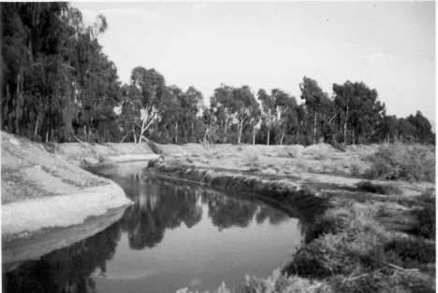
Figure 2
This site is a favorable place for migrant birds. These favorable conditions have created a natural recreational place in an arid and desert region. Visitors from far cities and villages admire the project's success (fig.2).

Conclusion

For the mentioned surveys the remote sensing science has been used. These surveys were put to the test in field studies. There was an increase in irrigated farms from 184 ha before initiation of the project to 2832 ha. The wind blown and poor rangelands were reduced from 7500 ha to 2352 ha, indicating that the system has directly or indirectly affected the environment of more than 10,000 ha of land. The results presented are the cases that could be surveyed through remote sensing. Changes in living microorganisms, chemical, physical and biological characteristics of soil as well as its fertility could not be surveyed through remote sensing. The essential success of this research is feasibility of comparison of the area under the project with other areas around the project through obvious documents, aerial photographs and satellite imageries. Optimal use of rainfall through floodwater systems not only reduces the negative effects of the flood in low lands but also reduces the water shortage during dry seasons. It needs a simple technology and little investment and promises an environmental development.

References

1. Curran, P.J.1986. Principles of remote sensing. Longman Scientific & Technical.NewYork. 282 P.
2. Fatehi Marj.A.1995.Evaluation of artificial groundwater recharges using mathematical methods. MS Tesis.ITC.Netherland.118P.
3. Jensen. J. R. 1986. Introductory digital image processing a remote sensing perspective. Prentice-Hall. New Jersey. 379 P.
4. Johannsen, C. J., T.W. Barney. 1981. Remote sensing applications for resource management’s. Journal of soil and water conservation. Vol. 26. No 3. P 128-131.
5.Kowsar.A.1991.Floodwater spreading for desertification control: An integrated approach. An Iranian contribution to the implementation of the plan of action to combat desertification. Desertification control bulletin (UNEP).Vol:19.P:3-18.
6.Kowsar.A.1993.The rooting zone: an in depth review of the soil depth. Research & Reconstruction. Scientific research & educational quarterly of Jahad-e-sazandegi.Vol:18.P:80-106.
7.Mesbahe.S.H.1998.Effects of flood water spreading on qualitative and quantitative change of vegetative cover on Gareh Bygone plain, Fars Research Center For Natural Resources and Animal Husbandry publication.no.19. 78 P.
8.Nejabat.M.1994. Satellite imagery application in land capability evaluation in the Gareh Bygone region, Fasa, the Fars province. MS Thesis. Tarbiat Modares university.Tehran.Iran.145 P.
9. Sabins, F.F. 1986. Remote sensing Principles and interpretation. Second. ed. W. H. Freeman and Co. San Francisco. 393P.

