Rain Collection as Water Source For Small Rural Communities in Chiapas, Mexico
( A case study: technical and social aspects for transferring of rural technology in Mexico)

Martín Mundo-Molina, Polioptro Martínez Austria, Romeo Ballinas Avendaño, Miguel Raúl Ponce, Edgar Rafael Penagos
Mexican Institute of Water Technology (IMTA), Mexico
E-mail: mmundo@tlaloc.imta.mx

Abstract

In Mexico there are many small rural communities with serious water supply deficiencies. The introduction of alternative, low-cost technologies represents means of supplying water such as through fog and rain catchment. In the state of Chiapas, in southern Mexico, research is under way on rain water collection for human consumption. This research can then be applied in communities in the states of Chiapas, Oaxaca, Guerrero, Veracruz, Puebla and throughout Baja California. In Chiapas, there are 19,972 poor rural communities, 15,712 of which have fewer than 100 inhabitants. The lack of a constant water supply is most severe in the highlands of Chiapas where the population is made up mainly of indigenous groups. The communities are on mountainous terrain with a widely dispersed population. These characteristics combine to make the provision of public utilities, such as water, electricity and sewerage, difficult with conventional means.

The combination of potability and low cost makes rain collection a viable alternative for rural areas, weather permitting. The Mexican Institute of Water Technology and Chiapas University constructed a rain water collector (RWC) in Yalentay Chiapas. The rain water collector constructed in Yalentay consists of four parts: 1. Roof of aluminum, for collecting rain water, 2. Underground-cistern, divided in two tanks, 3. Filters, to improve the water quality and 4. Regulator tank.

Background
In Mexico there are 198,311 rural communities (INEGI, 1998), with 24.154,775 inhabitants. In all the states of the Mexican Republic there is a serious problem of water supply for small rural communities. For technical or economical reasons conventional water supply technologies are not feasible. In order solve this problem, the Mexican Institute of Water Technology (IMTA) elaborated a handbook (for more information, call Martín Mundo-Molina. Phone and fax: (73) 19 40 12. Email: mmundo@tlaloc.imta.mx ) about alternatives technologies for rural communities. The first topic in the handbook deals with rainwater collection in small rural communities.

In this paper I show the most important characteristics of a rain water tank. The RWC was designed by IMTA to supply potable water to small rural communities with fewer than 500 inhabitants. A rain water collector was constructed in Yalentay, in the state of Chiapas, Mexico. Yalentay is an Indigenous Totzil community located 70 km from Tuxtla Gutierrez, in Chiapas, South Mexico.

With the financial support of the Agencia Española de Cooperación Internacional (AECI), IMTA and Chiapas State University constructed a rainwater tank and brought it to Yalentay.

Yalentay is located at 1700 meters above sea level. The climate of the region is tempered with rains in summer, the annual average rain is 1200 millimeters and the annual average temperature is 16º C.

In the highland of Chiapas the geographic characteristics and economic circumstances do not permit a water supply with conventional technologies. The majority of the indigenous people are lacking an adequate water supply system. For this reason there are many cases of "poverty diseases" such as cholera. Many of these small rural communities are far removed from the municipal administration or larger cities. They are located in the highland zones, they are quite dispersed or some don't even have a water fountain.

In Chiapas there are a total of 19,972 rural communities. Of these, 15,712 rural communities have less than 100 inhabitants. 41% of the state's population doesn't have potable water and 55,7% doesn't have sewer system.

In Yalentay, people say that the altitude and the dispersed population are the principal reasons why no water system has been introduced. The municipal government water supplied Yalentay with water trucks. Each family paid US$1,5 for each water truck that came to Yalentay.

During the last dry season, Yalentay was supplied with 29 water trucks. Each of these water trucks holds 6,000 liters. A total of 174,000 liters was supplied to Yalentay. This volume was consumed in 24 days considering that Yalentay has 400 inhabitants and each inhabitant consumed 18 liters per day. Rainwater collection could be an alternative for water supply for the rural communities in Mexico.

Rain water collector
Rainwater is collected from one's own thin roof. The underground cistern is an inverted and truncated pyramid with the minor base on the bottom (figure 1).

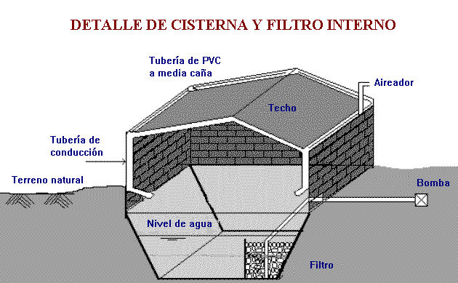
Fig. 1 Roof, walls, underground-cistern, filter of the rain water collector (Mundo et al, 1997).
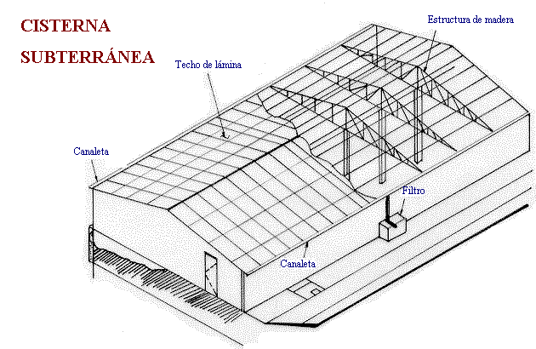

Fig. 2 Rain water collector constructed in Yalentay, Chiapas Mexico (Mundo et al, 1997).

The walls of the underground cistern have a slope of 1:1.5. The RWC walls were constructed and reinforced with chicken wire mesh.

Rainwater collection is made through lateral canals connected to PVC pipes, which take the rainwater to the underground cistern. The RWC has two filters (figure 1), compounded of sand and gravel layers. The water supply from RWC to Yalentay is by force of gravity, because the RWC was located in a highland zone. Inside the cistern, it is absolute dark in order to avoid water pollution by algae or insects (figure 2). The underground cistern has 12 ventilation pipes to maintain water quality. The RWC was constructed with region materials.

Maintenance
The RWC has two aces doors for internal cleaning, which should be done at least once a year. About every 12 months the roof and the canals should be cleaned. In order to maintain the water quality the filter should be checked every 12 months.

Technology transfer
Children's diseases in Yalentay are caused by the absence of water. In Yalentay there is no water for washing, drinking or any other uses. If women need water for their daily activities they have to walk a long distance to fetch it. It was due to the women that the RWC was immediately accepted in Yalentay.

To bring the RWC to Yalentay four activities were developed:
- Meetings for women, children and men
- Meetings with the local authorities
- Permanent communication among social and technical heads of the projects
- Interviews and permanent communication with the community in the survey process.

The meetings were held to clarify the social problems in relation to water. These meetings started with questions about the water supply in the community. For example: Which are the principal problems of the community? What do we do in order to confront this problem? The answers gave the researchers a good idea about social problems in Yalentay. The meetings with the local authorities had two objectives: first, to get information about the water problem in Yalentay and second, to inform the local authorities about the possibilities of passing on ideas about the project to the people. The local authorities received information about the internal community organization, and this was fundamental in the water patronage organization.

The social researchers were working permanently wit the people in Yalentay. They established the communication between technical researchers and the community.

Conclusions

The RWC constructed for Yalentay is low-cost and sustainable. The rainwater tank is an alternative for drinking water in rural communities in Mexico. Especially in places, where other water supply systems are not viable.

References
Instituto Nacional de Geografía e Informática (INEGI). 1998. http//inegi.com.mx.

Mundo Molina M.D., Martínez Austria P., Hernández Barrios L., Delgado Bocanegra A. (1997). Tecnologías alternativas en Hidráulica. Guía técnica para la selección. Instituto Mexicano de Tecnología del Agua. México.

