Technical Presentation of Various Types of Cisterns Built in the Rural Communities of the Semiarid Region of Brazil

Johann Gnadlinger
IRPAA, C. P. 21
48900-000 Juazeiro - BA, Brazil
E-mail: ircsa@netcap.com.br

Abstract

In this paper I will give a brief description of the technical aspects of some types of cisterns which are currently being built successfully in the rural communities of the Northeast. I will describe the advantages and disadvantages of the construction of certain types of cisterns. I will also mention my own observations collected during the building and the use over several years.

The types of cisterns are the following:
1. Concrete plate cistern
- Wire Mesh Concrete Cistern
- Brick cistern
- Reinforced concrete cistern
- Lime cistern
- Plastic cistern

1. Introduction
In this paper I will give a brief description of the technical aspects of some types of cisterns which are currently being built successfully in the rural communities of the Northeast of Brazil. I will describe the advantages and disadvantages of the construction of certain types of cisterns. I will also mention my own observations collected during the building and the use over several years. A list of necessary materials and costs for the various types of cisterns are attached.
The types of cisterns are the following:
1. Concrete plate cistern
- Wire mesh concrete Cistern
- Brick cistern
- Reinforced concrete cistern
- Lime cistern

- Concrete plate cistern
Concrete plate cisterns can be found throughout the Northeast of Brazil where they have been built with success. These cisterns were originally used in small farming communities and today small businesses and local governments are also building them.
The concrete plate cistern is buried in the ground at up to more or less two thirds of its total height. It consists of concrete plates (mixture cement: sand 1:4) of at least 50 to 60 cm, 3 cm thickness, curved in accordance with the projected radius of the cistern’s wall and depending on the anticipated capacity. There are versions where, for example, the concrete plates are smaller and thicker and made of a weaker cement mortar. These plates are made on site in simple wood forms. The wall of the cistern is erected with these fine plates based on the cemented ground. To prevent the wall from carving in during construction, it is sustained with rods until the mortar has dried.
After this a galvanized steel wire (2,77 mm) is wound around the outside of the wall and then plastered. (see illustration 1).
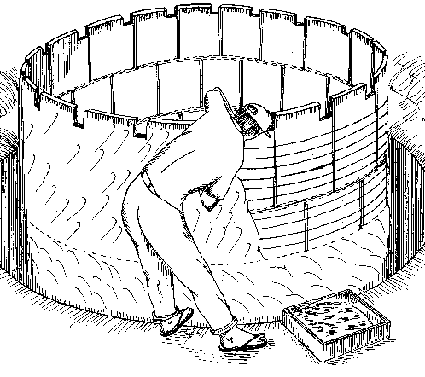 | 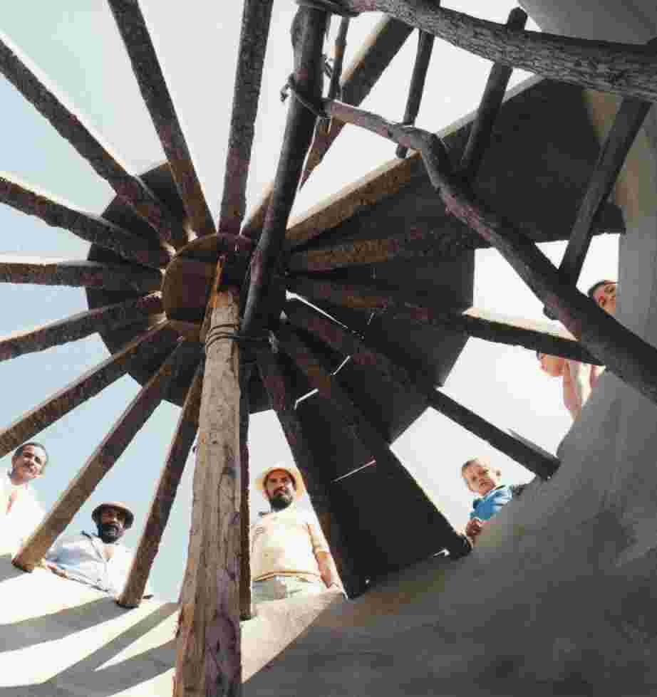
Illustration 1: Fitting of the wall and outside plastering of cement plate cistern | Illustration 2: Process of covering the cistern (inside view)

Following, the inside wall and the floor are plastered and covered with a fine layer of strong cement.
The cover of the cistern, conic and plain, is also made of concrete plates which are supported by narrow concrete rafters (see illustration 2). One external coat is enough to tighten it.
The empty space around the cistern is carefully filled up with earth. In this way the earth supports the cistern.
Advantages:
-the necessary tools, including the wood to make the forms, are available in all rural communities.
-the drawing of water happens easily from above, there is no need for a faucet;
-it is very adequate for small projects of cistern building, allowing the construction of a limited number of cisterns in a short time;
-low construction costs;
-the water is cool, since most of the cistern is underground.
Disadvantages:
-the construction requires qualified masons. For regular people it is difficult to trace a circle with the right radius for the fine wall on the foundation plates. The outline can only be off by 2 cm. To built the wall presents the same difficulty.
-the adherence between the concrete plates is insufficient, mainly in the horizontal direction. Tensions can cause cracks through which the water can leak;
-the underground part cannot be examined to detect leaks;
-the hole for the cistern has to be dug in a diameter 0,6 m larger than the diameter of the cistern itself in order to allow work on the outside wall. This means that for a cistern of 10 m³ an amount of 12 m³ has to be dug up (digging to a depth of 1,60 m).
-between the fabrication of the plates and the beginning of the building of the walls it is necessary to wait about three weeks in order for the concrete to dry sufficiently;
-the fixing of leaks is often impossible.

- Wire Mesh Concrete Cistern
This type of cistern is normally built above ground (see illustration 3). It has a height of two meters. Before setting the concrete floor it is only necessary to remove the soft earth. The ground is leveled to a depth of about 20 cm and a layer of gravel and coarse sand are put underneath a layer of concrete.
For the construction of this cistern a steel sheet form is needed. This consists of sheets of thin (0,9 mm) plain steel (1m x 2m) screwed together in a cylindrical fashion (see illustration 4).
The upright form is primarily wrapped with wire mesh, followed by galvanized steel wiring in a thickness of 2 or 4 mm, for cisterns with a capacity of 10 or 20 m³ respectively (see illustration 5). The wire mesh has to go underneath the form and has to cover a length of approximately 50 cm at the bottom of the cistern.
After putting on two layers of plaster on the outside (see illustration 6), the steel form is pulled out. The inside is plastered twice and afterwards covered with a fine layer of cement.
The cover of the cistern can also be made with the help of a steel form, but it is easier and quicker to use the same technologies as for the cement plate cistern.
In the intervals of the various stages of work and during the night the cistern has to be covered with a canvas to avoid a premature drying of the fine concrete wall which can cause a loss of resistance.
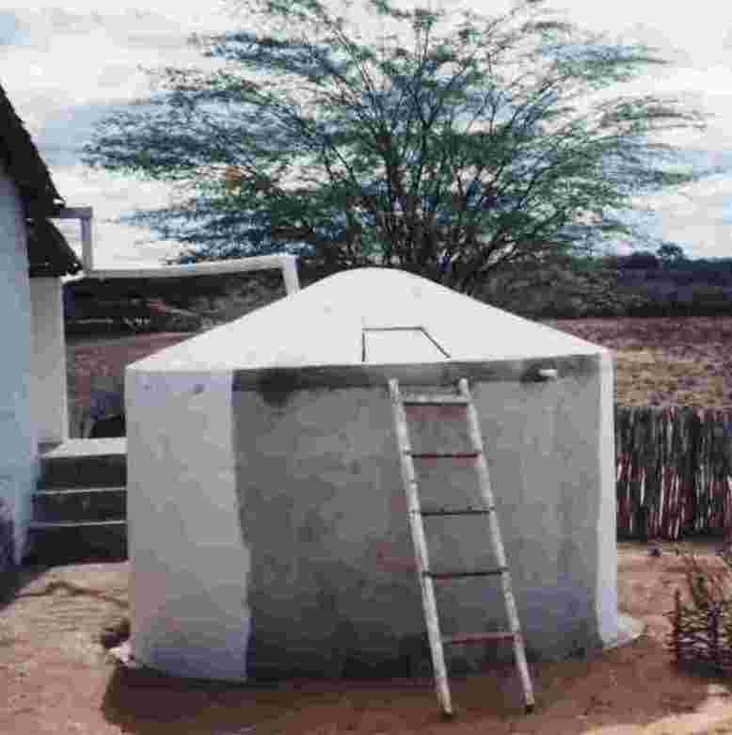 | 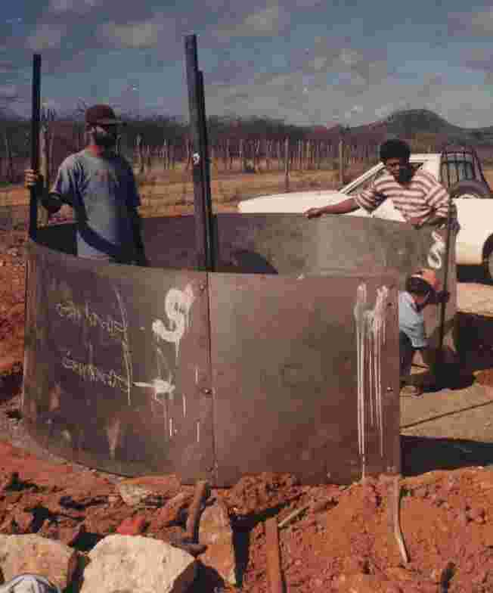
Illustration 3: 10 000 l wire-mesh concrete cistern | Illustration 4: Screwing of the steel sheet form

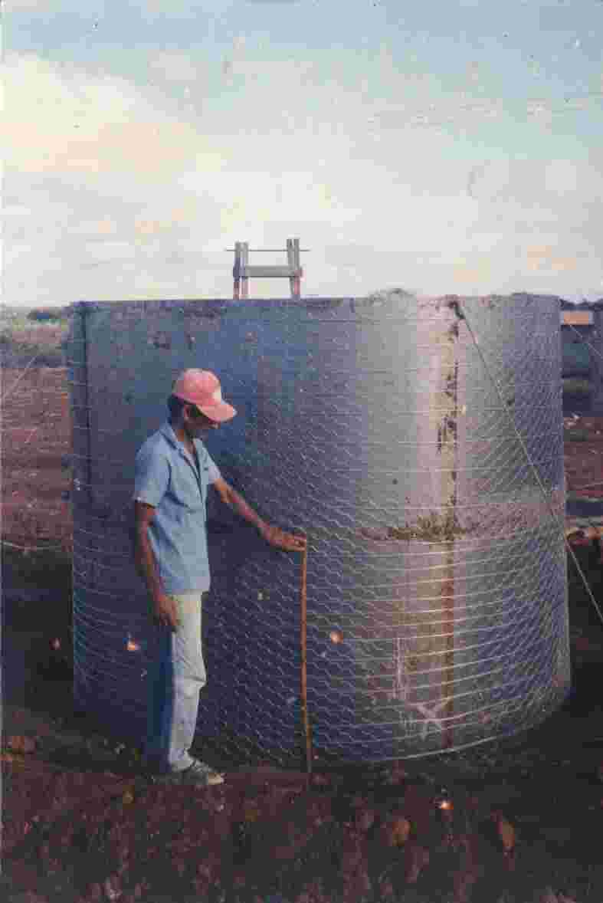 | 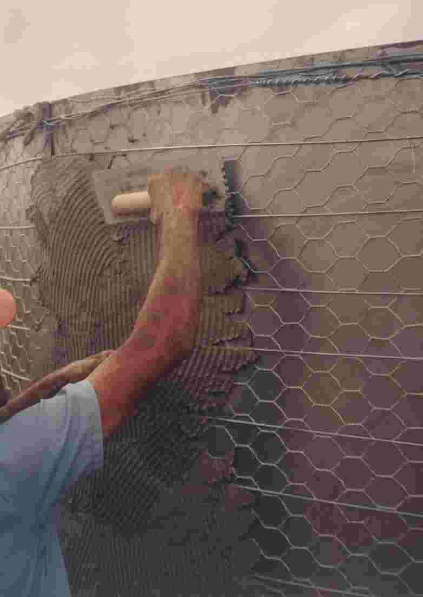
Illustration 5: Steel sheet form, wrapped by wire mesh and galvanized wire |  | Illustration 6: Application of the first layer of mortar on top of the wiring

Advantages:
-this way of constructing is similar to the way of building a mud house (something people know well and where the woven together wood structure is plastered together with mud on both sides);
-thus the technology is easily understood by the population;
-appropriate for small as well as big cistern construction projects -with little modifications in the structure of the cistern, this type can be adapted to be transported even over long distances, while the cisterns can be built at a central located site;
-the construction goes quickly;
-little use of prime materials;
-after having been used for the cylindrical forms the steel sheets can be used again and are easily transported in small pick-ups or even in carts;
-doesn’t require heavy digging work because the cistern is above ground;
-leaks can be easily discovered;
-possible leaks can be easily fixed.
Disadvantages:
-the use of steel sheets which are not always available everywhere in the countryside;
-the proportion between cement, water and sand has to be applied correctly;
-the walls may not dry during work and for the two following weeks;
-the water can heat up easily with the sun; for this reason the cistern has to be painted in white;
-the drawing of water is more complicated, it has to be done from above with the help of a small ladder or with the help of a faucet, increasing the risk of an accidental emptying;
-the construction work cannot be interrupted, otherwise the different layers of plaster don’t stick together sufficiently.

Dimensions of wire mesh concrete cisterns of 10 000, 20 000 and 40 000 liters
Volume | 10 000 liters | 20 000liters | 40 000 liters
Diameter | 2,5 m | 3,6 m | 5,2 m
Radius | 1,25 m | 1,8 m | 2,55 m
Height | 2 m | 2 m | 2 m
Circumference | 7,85 m | 11,3 m | 16 m
Thickness of wall | 4 cm | 5 cm | 6 cm
Foundation | remove the soft earth, 10 cm of pebbles and sand, 7,5 cm of concrete

- Brick cistern

This cistern is also two thirds underground like the cement plate cistern. It also requires a major digging out in order to work on the outside wall of the cistern.
The circular brick wall is put up on a concrete base. The thickness of the wall is about >20 cm. The wall is plastered on the inside as well as on the outside and covered with a fine layer of cement.
To assure greater elasticity, the mortar has to be made with cement and lime.
The cover of the cistern is level and made of concrete or even of wood beams topped with a fine layer of concrete.
Advantages:
-optimal for individual construction or for a neighborhood work party in rural communities;
-besides cement and a bit of iron, all the materials are locally available;
-the cistern turns out to be very cheap if local resources and work parties are used;
-the water remains fresh.
Disadvantages:
-if all the materials have to be bought, the cistern turns out to be expensive;
-takes long to be built;
-the risk of leaks between the cement floor and the wall are big;
-additional digging out work;
-for a bigger cistern the concrete cover is quite expensive because of the large diameter.
Observations:
In order to avoid leaks between the floor and the wall, one has to put wire mesh of one meter length in such a way that 50 cm cover the floor and 50 cm cover the wall before putting on the plaster. The cover can be replaced with barbed wire put on in regular intervals. The outside wall has to be wrapped with galvanized wire (or barbed wire). An additional need of material includes 8 meters of mesh and 135 meters of barbed wire for a cistern of 16 m³.

- Reinforced concrete cistern
The reinforced concrete cistern is particularly adequate for individual construction. On top of a concrete floor one builds a structure of steel wire (diameter of wire up to 5 mm). This structure is then wrapped up several times with wire mesh.
Two workers apply a first layer of mortar, one filling the structure while the other one secures a board or something similar against the other side of the wall being made.
It’s very important to use the right proportions of cement, water and sand, as well as the right use of canvas in order to avoid an early drying of the walls, which could cause a loss of stability.
Advantages:
-adequate for individual construction
Disadvantages:
-despite being the most solid one because of the use of steel which exceeds in many ways the quantity really needed, this type of construction is no longer advisable because it demands large quantities of industrial materials such as cement and steel and takes a long time.
-demands lots of skills from the masons, as much to build the wire structure as well as for the application of plaster.

- Lime cistern
The lime cistern is almost totally underground, in most cases only a small part of the upper part appears on the surface (see illustration 7). The earth is dug out in the exact size of the cistern. The floor of the cistern is concave. Inside the cistern looks like the inside of the broader half of an enormous eggshell (see illustration 8). One starts to build the cistern from the center of the bottom with bricks standing upright (see illustration 9). The walls are made with 20 cm thick bricks lined directly against the earth.
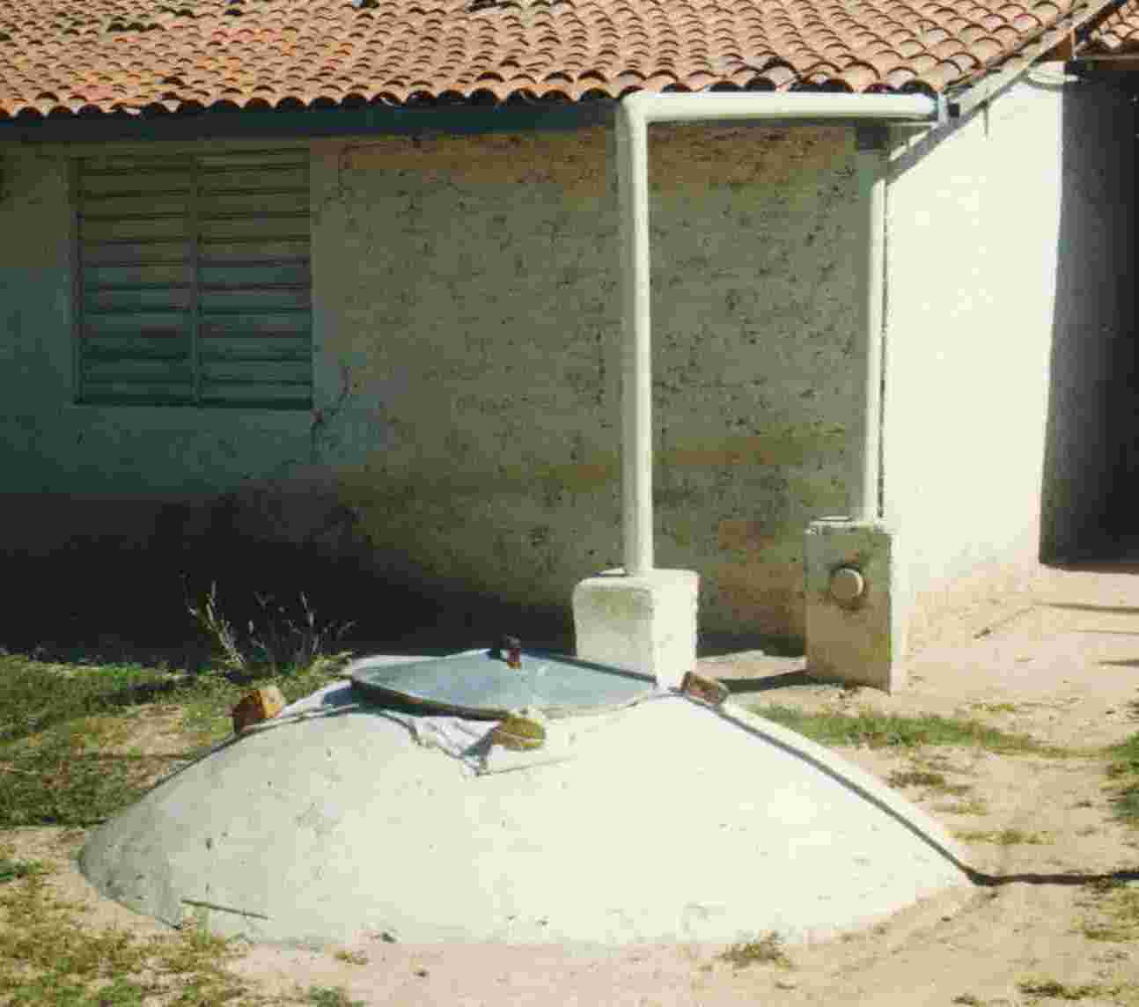 | 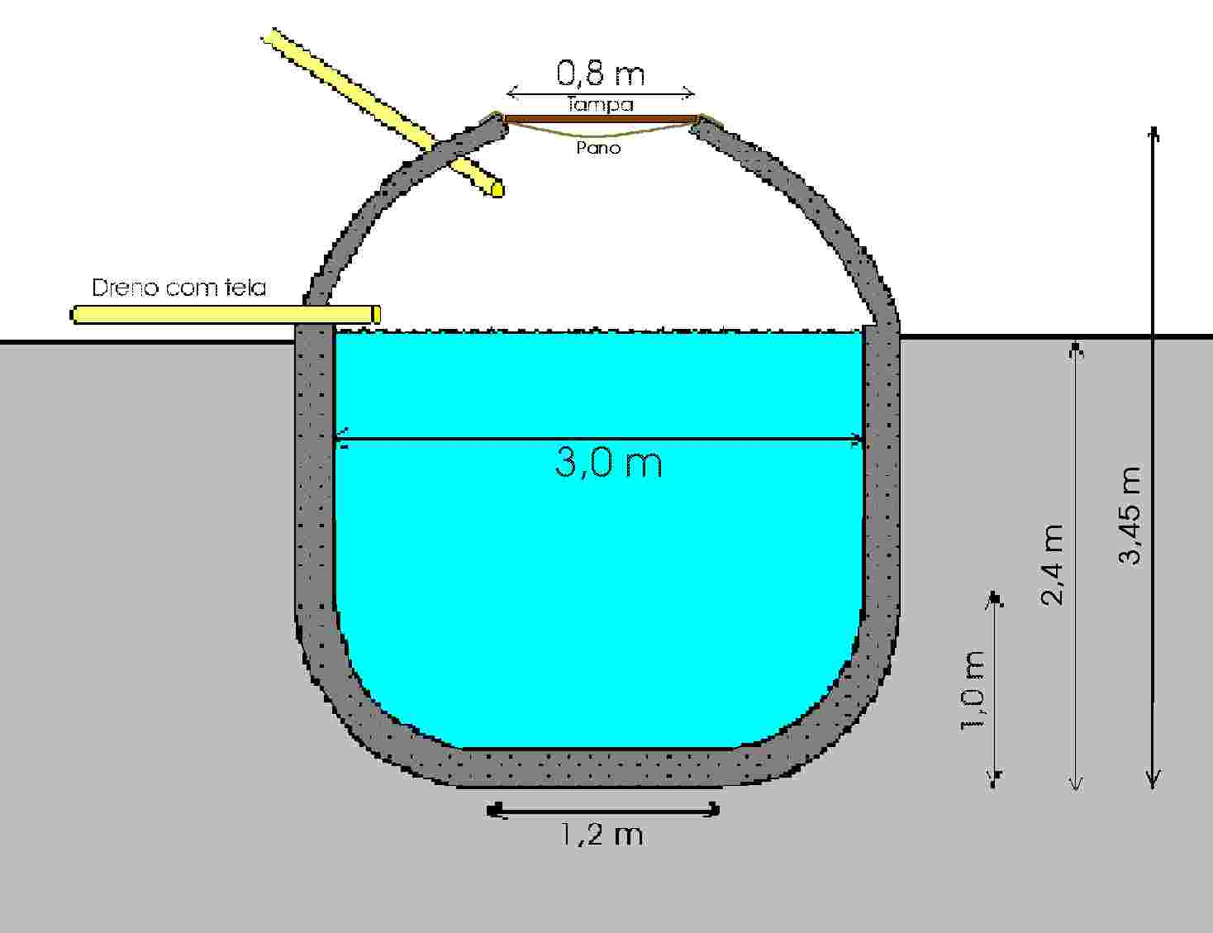
Illustration 7: Underground lime and bricks cistern | Illustration 8: Cross-cut of lime and bricks cistern  (10 000 l)

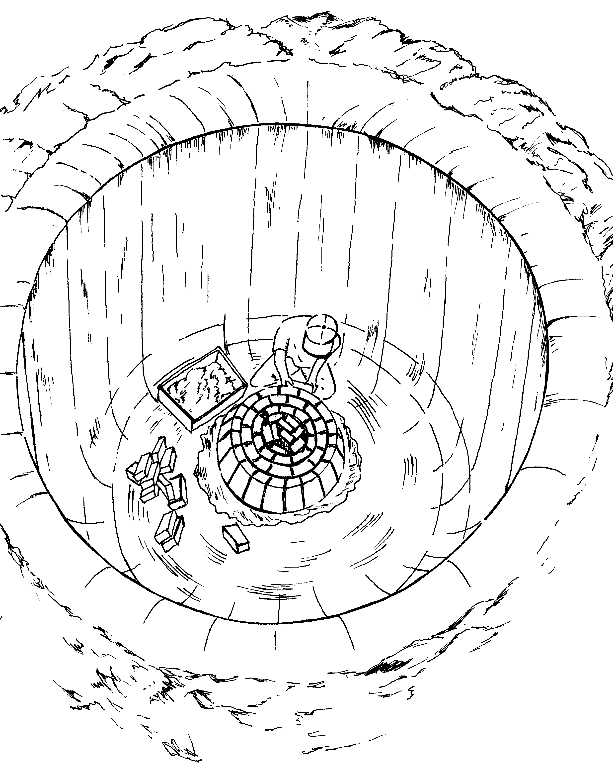 | 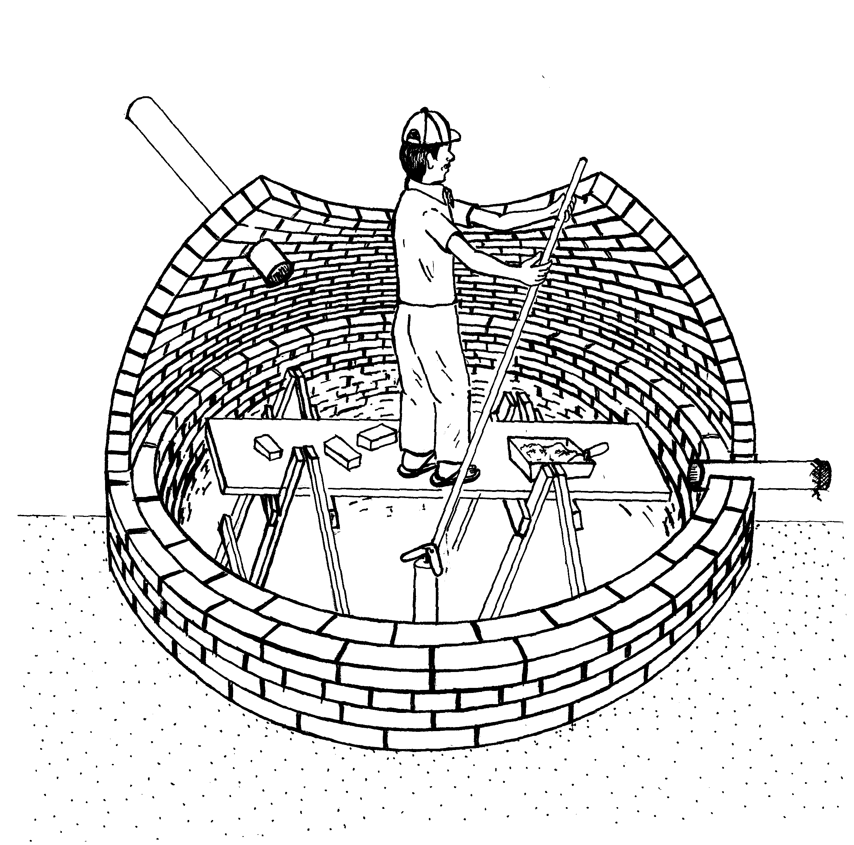
Illustration 9: Beginning of building of a cistern  of bricks and lime | Illustration 10: Covering the cistern with a brick dome
For the building one uses a plaster of pure lime. The internal plastering is applied twice or three times with a lime plaster to which is added a bit of cement and finally covered with a fine layer of cement water render.
The cover of the cistern can be made with planks, it could be a regular cover, but it has to be properly closed of to protect against the entry of small animals, or simply, it can be a brick dome (See illustration 10).
Advantages:
-except for some kilos of cement, all the construction materials are available everywhere in the country and can be produced by the farmer or can be obtained in local farming supplies stores;
-the construction techniques are well known, coal and lime furnaces are built the same way;
-the building method complements the life rhythm of the small farmers because construction doesn’t need to be done in one setting;
-the cistern can be built without any outside financial help;
-the walls built with lime are more resistant to pressure because lime is more elastic then cement.
Disadvantages:
-workers for digging are needed;
-the lime construction techniques are lost because of the widespread use of cement and very few masons still know how to work it;
-lime only becomes impermeable by using additives;
-lime needs more time to harden than cement.

- Rainwater catchment from the roof:
The various types of rainwater catchment described here are usually talking about the rainwater running off houses’ roofs. In the case of about 90% of houses the roof is big enough to guarantee an amount of drinkable water sufficient for all those living under its roof. But it is also possible to use a ground space for catchment if it has been cemented or covered with stones.
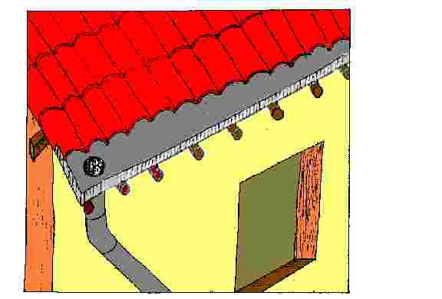
Illustration 11: L-shaped zinc gutter
The gutters and drop outlets to catch water from the roof can be of various materials: used PVC pipes cut in half, zinc sheets, even oil cans or wood. The gutters have to fit straight underneath the roof tiles in order to catch the heavy rainfall during thunderstorms. One way to catch water is to get a zinc sheet of 60 cm length, double it in L-shape and fit it straight under the last eaves of the roof rafters (see illustration 11).

4. The cistern resolves the water supply for the family
The water supply for a family always has to be established on an individual base. As each house has its own roof, each house has to have its own water supply.
Besides it is technically more difficult to have collective cisterns. The area to collect rainwater is limited and one has to think of the distances between the houses, normally a few hundred meters, but sometimes a few kilometers. The thing to do would be to have large areas for catchment on the ground and big collective cisterns meaning high costs for technical solutions.
We suggest to build cisterns holding a maximum of 20 000 liters, with little risk of cracking and using cheap construction material.
A collective cistern has to have a minimum volume of 160 000 liters in order to guarantee the water supply of ten houses during 8 months of dryness.
A cistern construction program is only advisable if all the houses in a community can have their cisterns built within a short time frame. If only one or a few houses build a cistern, the other people from the community will go there to fetch water during the next dry period and the cistern will be empty quickly.

5. Conclusion
To live with a cistern demands discipline: one has to learn to use water with parsimony; the areas of catchment have to be clean; the gutters have to be kept in good working condition; water cannot be retrieved with pails which had been put on the ground in order to avoid contamination. An installation for rainwater catchment can supply drinking water of good quality. It is a one time investment, doesn’t bring about maintenance costs, is a fixed structure and maintenance is so simple children can even do it. On top it, it is the ecologically most correct solution.
What makes installation difficult are organizational questions. Mostly people don’t have the desire to actively participate in a water supply program. But to be efficient a program needs lots of community participation otherwise it is not possible to pay for the installations. The community has to be convinced that this is a good solution. This requires a well developed coordinating work over years.
But a house with a cistern means a decisive change in the traditional ways of the people in the Northeast. Until today, life in the Northeast means to be slowed down by nature, by the seasons, without active participation in what’s happening, without interfering in anything in one’s own favor. When people build cisterns to catch rain water and when they can take care of their families thirst during a drought with this water, it means a first step for the rural population to integrate itself actively into the life cycles of a semiarid region and to resolve a vital problem, that is, to have enough water for the survival of a family. But we know too: As long as survival is not guaranteed, cisterns only mean a temporary relief and people will wait for the moment when they can migrate to the big cities.

References:
Bernat, Courcier, Sabourin, Cisternas de placas, técnicas de construção, Ed. Massangana, Recife - PE, 1993
Gnadlinger J, A Busca da Água no Sertão, Ed. Fonte Viva, Paulo Afonso - BA, 1996³
Gnadlinger J, Cisterns for Rural Low Income Communities in Northeast Brazil, 7th IRCSA Proceedings, Beijing, China, 1995
Gnadlinger J, Redescobrindo a Cal para construir Cisternas, Paulo Afonso - BA, 1999
Schistek H, A Construção de Cisternas de Tela e Arame. Paulo Afonso - BA, 1998
Silva, A. de S., Brito, L. T. de L. & Rocha, H. M., Captação e Conservação de Água de Chuva no Semi-árido Brasileiro, Cisternas Rurais II, Água para o Consumo Humano, CPATSA-Embrapa, Petrolina-PE, 1988.
Watt, S B, Ferrocement Water Tanks and their construction, Intermediate Technology Publications, London, 1978

Illustrations 1, 6 e 7: José Ivomar Pereira de Sá
Illustrations 2, 3 e 4: Harald Schistek
Illustrations 5 e 8: Johann Gnadlinger

Attachment:

Budget for various types of cisterns
Data of Juazeiro, Bahia State, of 1997 and 1998
1 R$ = 0,6 US$ (June 22,99)

1.a. List of materials and budget for the building of a CEMENT PLATE CISTERN of
10 000 liters:
radius: 1,15 m, diameter: 2,30 m, height: 2,40 m
quantity | material | price per unit | total price
11 | cement/bag | 7,00 | 77,00
70 | cans of sand (transport) | 0,10 | 7,00
7 | cans of rock/pebbles | 1,00 | 7,00
1.100 | liters of water |  | 0,00
4,5 | kg of iron 1/4 | 1,00 | 4,50
10 | kg of wire 12 galvanized | 1,14 | 11,40
 |  | total | 106,90
5 | days of mason work and mason’s helper | 22,5 | 112,50
 |  | Total R$ | 219,40

1. b. List of materials and budget for the building of a CEMENT PLATE CISTERN of 20.000 liters
radius: 1,63 m, diameter: 3,26 m, height, 2,4 m

quantity | material | price per unit |  | total price
18 | cement/bag |  | 7,00 |  | 126,00
114 | cans of sand (transport) |  | 0,10 |  | 11,40
10 | cans of rock/pebbles |  | 1,00 |  | 10,00
1.800 | liters of water |  |  |  | 0,00
7,5 | kg of iron ¼ |  | 1,00 |  | 7,50
14 | kg of wire 12 galvanized |  | 1,14 |  | 15,96
 |  |  | total |  | 170,86
8 | days of mason work and mason’s helper |  | 22,50 |  | 180,00
 |  |  | Total R$ |  | 350,86

2. a. List of materials and budget for the building of a WIRE MESH CEMENT CISTERN of 10 000 liters
quantity | material |  | price per unit |  | total price
13 | cement/bag |  | 7,00 |  | 91,00
1,5 | sand m 3 |  | 11,00 |  | 16,50
0,8 | rocks/pebbles m 3 |  | 16,00 |  | 12,80
9 | m wire/chicken 2,5 m height |  | 3,00 |  | 27,00
12,8 | kg of wire 12 galvanized |  | 1,14 |  | 14,59
 |  |  | Total |  | 161,89
3,5 | days of mason work and mason’s helper |  | 22,50 |  | 78,75
 |  |  | Total R$ |  | 240,64
2. b. List of materials and budget for the building of a WIRE MESH CEMENT CISTERN of
20 000 liters
quantity | material | price per unit |  | total price
22 | bags of cement | 7,00 |  | 154,00
2,5 | m 3 sand | 11,00 |  | 27,50
1,3 | m 3 rock/pebbles | 16,00 |  | 20,80
11,5 | m wire/chicken 2,5 m height | 3,00 |  | 34,50
51 | kg of wire 8 galvanized | 1,14 |  | 58,14
 |  | total |  | 294,94
4,5 | days of mason work and mason’s helper | 22,50 |  | 101,25
 |  | Total R$ |  | 396,19

2. c. Material and budget for the steel sheet form of a cistern of 10 000 liters

quantity | description | length | dimension | weight/unit | price/kg | value
5 | steel stakes | 2,4 | 1 1/2 x 3/16 | 2,67 | 0,88 | 28,20
10 | steel ring parts | 2,14 | 1 1/2 x 1/8 | 0,95 | 0,84 | 17,08
9 | steel sheets 20 (0,9 mm) |  |  | 2 x 1 m | 14,40 | 1,14 | 147,74
25 | carriage bolts |  |  |  | price/unit
 |  | 1 1/2 |  |  | 0,20 | 5,00
20 | machine bolts
 |  |  |  |  | 0,20 | 4,00
 |  |  |  |  | Total | 202,02

3. List of materials and budget for the building of a BRICK CISTERN of 15 500 liters
quantity | material | price per unit. | Total price
4.000 | bricks | 0,025 | 100,00
15 | cement bags | 7,80 | 117,00
10 | lime bags | 2,20 | 22,00
0,5 | m 3 rock/pebbles | 70,00 | 35,00
48 | kg iron of 1/4" | 1,00 | 48,00
 |  | total | 322,00
6 | days of mason work and mason’s helper | 15,00 | 90,00
 |  | Total R$ | 412,00

4. List of materials and budget for the building of a LIME CISTERN:

 |  | Cistern of 10.000 liters |  | Cistern of 20.000 liters
 | Price/ Unit | Quantity | Price R$ | Quantity | Price R$
Digging Out | m³ | 12 |  | 22
Cans of quick lime | 1.60/can | 16 | 25.50 | 31 | 49.60
Cement | 7.00/bag | 1 | 7.00 | 2 | 14.00
Bricks | 40.00/per thousand | 3500 | 140.00 | 6000 | 240.00
Work (mason + helper) | days | 10 | 150.00 | 16 | 240.00
 | Total |  | 322.50 |  | 543.60
 | Total excluding work |  | 172.50 |  | 303.60
Observation:
If the bricks and the lime are produced in the community and if no one is employed, the lime cistern can be built at no monetary costs.

5. Budget and estimated material use for roof water catchment for a cistern of
15 500 liters
quantity | material | price per unit | total price
10 | m galvanized sheet, 50 cm width | 2,80 | 28,00
4 | m PVC pipe 4" | 10,00 | 10,00
1 | joints | 2,50 | 2,50
 |  | Total R$ | 40,50

