Experiences gained in the development of rainwater catchment in Tanzania

Datius G. Rutashobya
(Director for Africa Region, IRCSA)
Ministry of Water
P.O. Box 35066 Dar es Salaam, Tanzania
Tel.: 255 51 451463
Fax: 255 51 451457
E-mail: rutashobya.d@raha.com

Abstract

As is the case in many African countries, rainwater catchment technologies have been used on a rudimentary level in Tanzania for a long time. Until recently, however, they have not made a significant impact in solving rural and urban water supply problems. Currently, various stakeholders are paying more attention to rainwater catchment as a means of supplementing the conventional water supply options such as piped water schemes, deep and shallow wells and springs. The shift in attitude among the decision-makers has been influenced by the realisation of the high potential of rainwater harvesting.

Over the past few years, efforts have been stepped up by the government as well as other organisations in developing rainwater-harvesting systems throughout the country. The whole process started with awareness creation and sensitisation on the importance and potential of rainwater harvesting technologies. Low cost demonstration rainwater harvesting cisterns are being constructed at strategic locations across country and people are being trained in the construction of low cost rainwater storage systems. Experience has shown that the demonstration tanks and other cisterns are playing a key role in sensitising the people, who have responded by constructing rainwater catchment systems with their own resources.

1. Introduction

Experience with rainwater catchment has a long history in Tanzania but most ancient systems have fallen into disuse. Individual communities have long practised rainwater catchment on a small scale as a traditional method to improve the availability of water.

Rainwater harvesting (RWH) has been applied as a source of water supply for a very long time. However it has not been developed to such a level that it can be a significant part of the country’s water resources. Water authorities, including international donors involved in water development, have not favoured this technology but have, instead, mostly applied sophisticated technologies to develop both surface and ground water. Lately, however, the application of RWH techniques has been considered one of the ways to solve water supply problems for domestic, livestock, crop production and for industrial purposes. These techniques have regained importance and some organisations are now looking at their potential applications. Most attention has been focused to roof top catchment.

Over the last twenty years or so various external support agencies (ESA) have funded RWH projects in the country. These include CIDA, Sida, UNICEF, UNDP, African Medical Research Foundation (AMREF), Tanganyika Christian Refugee Services (TCRS), Water Aid (a British support agency), DANIDA, FINNIDA, NORAD and International Development Research Centre (IDRC) of Canada.
2. Need for rainwater catchment in Tanzania

Rainwater harvesting is a feasible option for improving the living conditions of millions of Tanzanians currently facing serious water supply problems. It is a very attractive supplement to traditional or improved water sources because it relieves the burden of water collection by bringing it closer to the homes and lowers the pressure on finite groundwater sources (Lee and Visscher, 1992). As much as 63% of the rural population is currently relying on unimproved traditional water points, which include shallow water holes, ponds, lakes, permanent or seasonal rivers, springs and shallow groundwater accessed by hand-dug wells.

Over the years water authorities, including international donors involved in water development, have mostly favoured application of sophisticated machineries in the development of both surface and groundwater. Unfortunately, these conventional techniques of water supply have proved to be too expensive to operate and maintain, in view of the poor economic standing of the country. The cost of developing new water sources through such technologies is often not affordable by the government. Also, there is commonly a shortage of technically trained personnel of various cadres needed to plan, design, construct, operate and maintain water schemes. Further, there are areas where people have to go a long way to fetch water. It is evident therefore that simple, cheap, appropriate and affordable technologies are necessary when developing new water sources, in order to provide people with sustainable water supplies. One of such technologies is rainwater catchment.

A lot of valuable time, particularly in rural areas, is spent on walking long distances to fetch water. If runoff water were collected efficiently, millions of Tanzanian women, who are the ones who collect water, would be saved the burden of trekking to far away water sources. The time saved through walking shorter distances would be devoted to activities designed to improving the living conditions of the rural dwellers. There is often sufficient water available to supply drinking and agricultural needs through the dry season if only rainfall and runoff are captured and stored for later use.

Rainwater harvesting may be a supplement, an alternative supply or the only feasible supply in many parts of Tanzania, especially in the arid and semiarid areas.

3. Strategies undertaken

3.1 Awareness creation

Efforts are being made to sensitise and create awareness among relevant people at
national, district and village levels on the importance and potential of the rainwater harvesting technology. To achieve this a number of approaches are
being used.

It was conceived that not all decision-makers are well sensitised on the importance of RWH. In order to raise the level of understanding and appreciation of the RWH technology among decision-makers, top government officials have been visiting countries where RWH has been practised for a long time. Other officers in the middle and lower cadres have also been exposed to such practices for a similar purpose. Alongside this strategy, posters, brochures and other audio-visuals carrying educational messages on RWH are being produced and disseminated to different parts of the country. It is expected that these materials will serve to instil a positive view among various stakeholders towards the RWH technology.

3.2 Training

Training geared at building capacity to construct rainwater catchment cisterns in the districts and villages was considered essential. This activity has been carried out in order to create teams of people capable of constructing low cost tanks for rainwater storage. UNICEF and UNDP have been in the forefront in supporting this initiative.

Training sessions are usually practical-oriented whereby participants, apart from being given a brief theoretical background on rainwater catchment, are shown how to construct low cost rainwater storage tanks of various types and capacities. They then construct the tanks
themselves. Figure 1 shows a training session conducted at Lulumba Secondary School in Iramba district, during which a 20,000 litre ferrocement standing tank was constructed. Figure 2 shows another training session for a 52,000 litre sub-surface tank conducted at Nzega town.

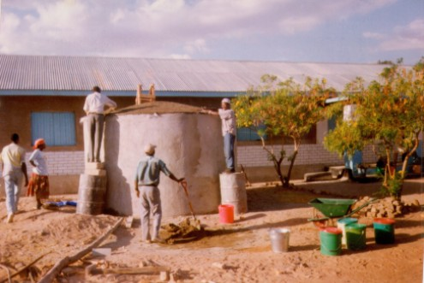
Figure 1: Construction of a 20,000 litre ferrocement tank at Lulumba Secondary School, Iramba district

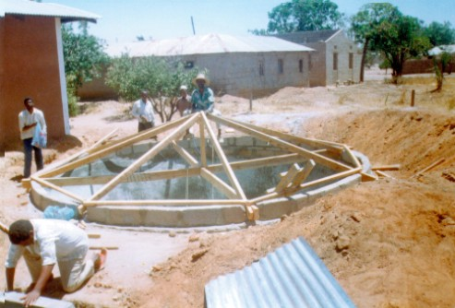

Figure 2: Construction of 52,000 litre sub-surface tank at Nzega town
Trainees are usually drawn from some of the semiarid districts of Tanzania, which stand to benefit most from RWH. Venues where training sessions are conducted as well as participants of the training are normally selected by the district authorities. Participants are mostly drawn from the water, health and community development offices in each of the participating districts. Further, selected village artisans do participate in the training.

3.1 Demonstration rainwater catchment systems

Rooftop catchment systems

Tanks of different sizes have been constructed in different locations, with concentration in the semiarid areas. The tanks are part of the rooftop harvesting systems that are located mostly in public places like schools, hospitals and health centres.

Construction has been carried out by those who underwent training as explained under 3.2 above. Whereas the majority of these systems consist of tanks ranging in size between 1 m³ and 50 m³ there are systems of much larger capacity. An example is a roof catchment system built at Mkonze Primary school, in suburban Dodoma town through funding by UNDP in Tanzania. The system involves a 1250 m² catchment surface, which collects rainwater into a 675 m³ underground trapezoidal tank of poultry mesh reinforced cement-coated asphalt lining. The tank is covered by galvanised iron roofing. Seepage is controlled by the asphalt lining and evaporation is controlled by galvanised iron roofing which also collects rainwater into the tank. A hand pump draws the water through a sand filter in a 1000 litre plastic tank where it is biologically purified. Experience has shown that this system is too costly and too labour intensive to be replicated by the rural communities (Kifua, 1997).

The strategic location of the rainwater catchment systems is to ensure that as many people as possible, see them. It is hoped that these demonstration systems will help to popularise the RWH technology in those areas through replication by individuals, communities and institutions. There has been great interest in the rainwater tanks has been shown during construction and a number of individuals and institutions in the pilot areas have requested the construction of tanks at their own costs. Figure 3 is a demonstration RWH system with a 23,000 litre ferrocement tank at Mburahati dispensary, in Tanzania's capital Dar es Salaam.

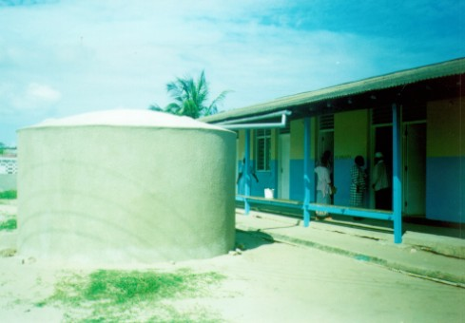
Figure 3: Demonstration rooftop catchment system at Mburahati dispensary, Dar es Salaam

3.3.2 Ground catchment systems

Such systems have been constructed in large numbers particularly for stock and crop watering in the dry areas of the country. They include “charco” dams, earth dams and excavated reservoirs.

Some ground catchment systems are utilised for domestic water supply like rock catchments and paved surfaces. An example of the latter is the system constructed at Iyumbu village in Dodoma. It involves a 60m x 30m artificial catchment surface of poultry mesh reinforced cement-coated plastic sheeting. The rainwater is collected into a 760 m³ circular reinforced cement-block underground tank. The tank is covered by a galvanised iron roofing which also collects rainwater into the tank. The water is drawn by a Nira 6 hand pump through a sand filter in a 1,000 liter plastic tank where it is biologically purified.

The system has proved to be oversized, too labour intensive and too costly to be replicated by the rural communities.

3.3.3 Sand storage dams

Sand storage dams (also called sand dams) are watertight weirs keyed into the floor and banks of sand rivers, with their heights extended to several metres above the level of sandbeds.

In Tanzania sand storage dams, built of stone masonry, concrete blocks or concrete, have been constructed on different locations in sand rivers. Three such dams were constructed, one at Mkonze village on Bwenzeru stream and two at Iyumbu village on Chimwaga and Magwilo. Water is drawn by gravity fed tap on the Chimwaga and by Nira AF 85 hand pumps through sumps constructed in the riverbanks on the Bwenzeru and Magwilo. Gravel-packed perforated 10cm PVC pipes draw the water by gravity from the sand reservoirs into the cement-block masonry sumps. Being the only improved source of water and having been fitted with mechanised extraction, the water of these schemes is being used for 8-9 months, which is 3-4 months into the dry season.

3.3.4 Sub-surface dams

Sub-surface dams have been constructed in a few locations in river channels in the country. Recently, one sub-surface dam of concrete-block masonry has been constructed at Mkonze village on Mkonze stream. This scheme holds water 10-11 months, which is 6 months into the dry season.

In Mkoyo village, one clay-core and one stone-masonry sub-surface dams have been constructed at Nhundulu on Nkhole stream and Nyamwanji on Nkambala stream respectively. The Nhundulu scheme supplies water till October while the Nyamwanji one supplies water throughout the year.

4.0 Experiences

4.1 Successes recorded

In Tanzania, rainwater harvesting is now receiving serious attention from the government and ESAs. It is now being recognised as one of the potential sources to help meet the national objective to provide clean and safe water within 400 metres of every home by the year 2002.

Many rooftop catchment systems have commonly been constructed by missionaries and ESAs around the country in churches, schools, hospitals and community centres (Rutashobya, 1992). Ground catchment and rock catchment systems have been constructed in many locations, especially in the southern part of Tanzania.

As already mentioned, in the last couple of years, the national RWH programme has been actively supported by UNICEF and UNDP through which many RWH systems have been built. The results are that many people are now relying on rainwater. Also, more people are increasingly recognising the importance and benefits of the RWH technology and are now building rainwater catchment systems with their own resources.

In order to accelerate the RHW initiatives a 5-year National Rainwater Harvesting Action Plan is currently under preparation. The plan will indicate activities requiring immediate, short-term and long-term action in the promotion and development of RWH in Tanzania (Rutashobya, 1998).

4.2 Problems and Obstacles encountered

A number of problems are usually encountered in the course of implementation of the efforts to spread the RWH technology. Some of these are mentioned below.

In some areas a good number of rural houses are thatch-roofed, making rooftop catchment unsuitable
A large percentage of the population, especially in rural areas, cannot meet the cost of construction of RWH systems
Surface water dams are subjected to high sedimentation and evaporation. Overstocking, which is common in the semiarid areas where these dams are mostly located, promotes soil erosion which aggravates sedimentation of the dams.
There is a problem of scouring downstream of the sand-storage dams. This problem persists even with measures like construction of stone-masonry aprons on the downstream side of the dam walls.

5.0 Conclusions

The rainwater catchment technology has a high potential of success in Tanzania. This is based on the experiences recorded in those areas where it has been applied. The technology is simple, relatively cheap and appropriate to the national socio-economic setting. Since many people have shown eagerness to apply rainwater harvesting the technology must be spread in the country as much as possible. It is therefore important that RWH forms part of the national strategic objectives for solving the current water supply problems of the country.

References

Kifua G.M. Rainwater Harvesting Potential in Dodoma Region, Tanzania, 1997 (Unpublished report).

Lee M.D. and Visscher J.T. Water Harvesting in Five African Countries. Occasional Paper 14, p1. IRC International Water and Sanitation Centre, The Hague, 1990.

Rutashobya D.G. Current Efforts in the Development of Rainwater Harvesting in Tanzania.: In Proceedings of the 17th Annual Water Experts Conference, p97. Arusha, 1998.

Rutashobya D.G. Rainwater Harvesting as a Potential Solution to Water Supply Problems: A Case of Tanzania. In Global Water Use Under Limited Water Situation: Proceedings of the 1992 Regional Conference of the International Rainwater Catchment Systems Association, Volume 1, p312. Kyoto, 1992 Ed. Isao Minami.

